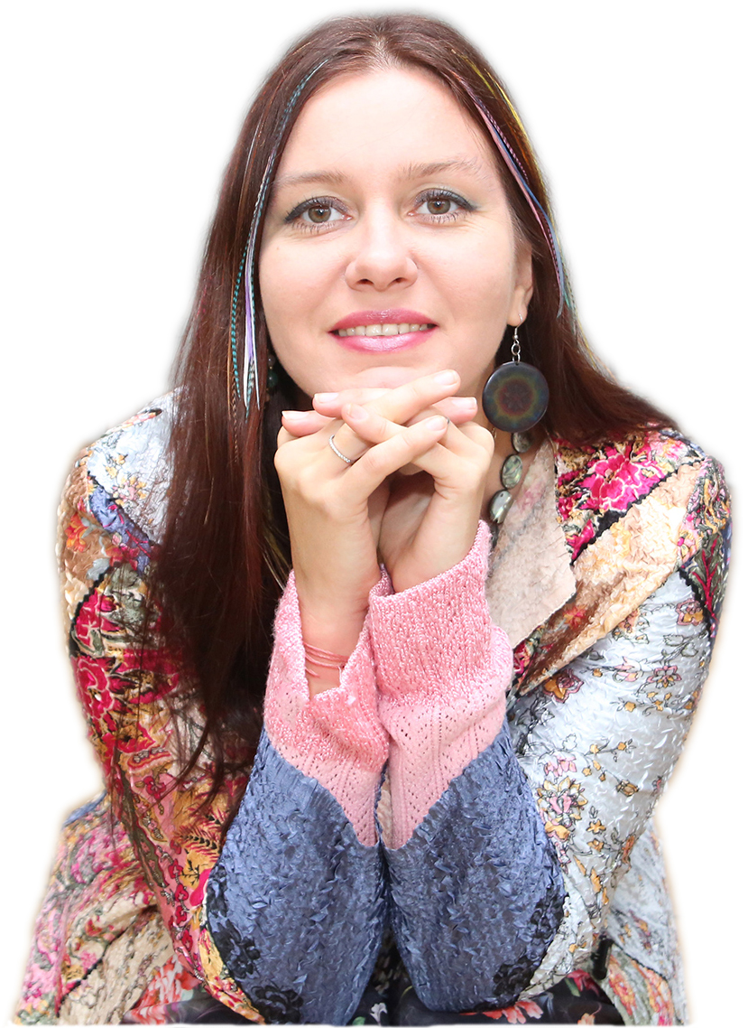**EKATERINA ABRAMOVA** is an artist, specializing in painting and graphic arts in mixed as well as traditional techniques using oil, acrylic, markers, etc.

Although being a multifaceted artist, her style could be described as going in two major directions: the 21st century Post-Expressionism, and Spiritual Ornamental paintings drawn on symbolic folk art of various peoples, most notably on Russian and Indian mythology. Born in 1979 in Moscow, she graduated from an art school with honors and continued her studies at the Vasnetsov College of Fine Arts, Moscow. In 2007 she received her MFA from the I.E. Repin State Academy of Fine Arts, St. Petersburg, Russia. Her numerous awards include Gold Medal “250th anniversary of the Russian Academy of Arts,” Gold Medal “National Treasure” of the International Charity Fund “Philanthropists of the Century”, citation from the Russian Academy of Fine Arts for the participation in the exhibition dedicated to the 250th anniversary of the Academy, the Peacekeeper Fund Medal, among others. She was nominated for the State Presidential Scholarship in the Arts. She is a member of the Union of Russian Artists, Art Fund International, Creative Union of Professional Artists, Art Indulge Foundation.

In 2014, she was awarded an International Artist Residency in Hyderabad, India, organized by the State Fine Art Gallery and Kalanirvana Foundation, to represent Russia among 20 other artists from all over the world; as well as similar artist residency in Goa Chitra Museum, Goa, India.

And in 2015, she has been awarded a 3-month International Artist Residency, curated by Eileen Kaminsky Foundation at Mana Contemporary Art Complex in Jersey City, NJ, during which she will make 10 paintings of her new series Placenta starting September 2016.

Among her most recent exhibitions are: *Miami River Art Fair,* Miami, Florida, December 2015; *Artnado Art Fair,* West Palm Beach, Florida, USA, November 2015; *Exhibition “Expressions of Color”* at Gateway Arts Center, New York City, USA, May 2015; *Exhibition “Take Your Breath Away” at the Victoria Space, Art Factory,* Paterson , NJ, USA, June 2015; *Kolkata Art Biennale*, Kolkata, India, April 2015; *Exhibition ArtExpo New York*, New York City, USA, April 2015; *Art India Festival*, Mumbai, India, November 2014; *Exhibition Golden Age, Russian Cultural Centre*, Berlin, Germany, November 2014; *Exhibition Innovation of Color*, *Westside Park Art Gallery,* New York City, USA, October 2014; *Woman’s Academy*, Moscow, September 2014; *Exhibition Art Through Light II at the State Gallery of Fine Art,* Hyderabad, India, September 2014; *Exhibition On The Right Way, Central Artist’s House,* Moscow, September 2014; *Exhibition ArtExpo New York*, New York City, USA, April 2014; *Exhibition Artistry at Artery Fine Art Gallery,* Chicago, USA, February 2014; *Art Cocktail Exhibition at D.E.V.E. Gallery*, Bruges, Belgium, November 2013.

She has had numerous personal exhibitions of her art all over Europe, India, China, and USA.

Her works are in private collections in UK, France, Germany, Russia, Belgium, Finland, Italy, Switzerland, China, India, and USA.

She lives and works in New York.

**EDUCATION**

1996-1999 Vasnetsov College of Fine Arts, Moscow, Russia

2007 I.E. Repin Academy Of Fine Arts, St. Petersburg, Russia

**SOLO EXHIBITIONS**

2015 *Exhibition Expressions of Color*, *The Gateway Art Center*. New York, NY, USA

2014 *Woman’s Academy*, Moscow, RUSSIA

2013 *The Nefta Gallery.* Voronezh, RUSSIA

2013 *Galaxy*. Guttenberg, NJ, USA

2012 *Russian Center of Science and Culture*. New Delhi, INDIA

2011 *Embassy of India in Russia.* Moscow, RUSSIA

*Fusion Art Gallery*. Moscow, RUSSIA

2010 *Тilting Art Gallery*. Pune, INDIA

2009 *Open Air Gallery*. Goa, INDIA

*Cultural Center Rossinka.* Moscow, RUSSIA

2008 *Art Fund International*. Moscow, RUSSIA

*The German House.* Moscow, RUSSIA

*Castle Burg Hohenklingen*. SWITZERLAND

*Embassy of Russian Federation in Switzerland.* Bern, SWITZERLAND

2007 *Landrasampt.* Konstantz, GERMANY

2006 *German House*. Moscow, RUSSIA

*Elena Art Gallery*. Central House of Artists, MOSCOW

2005 *Bezh Gallery.* Moscow, RUSSIA

2003 *Art Business Gallery.* St. Petersburg, RUSSIA

2001 *Arte Vita Gallery.* Moscow, RUSSIA

1999–2001 *Embassy of Germany in Russia.* Moscow, RUSSIA

2000 *German-Russian House*. Moscow, RUSSIA

*Embassy of Finland in Russia*. Moscow, RUSSIA

1998 *House of People’s Friendship*. Moscow, RUSSIA

**SELECTED GROUP EXHIBITIONS**

2015 *Miami River Art Fair*. Miami, FL, USA

*Artnado Art Fair.* West Palm Beach, FL, USA,

*Exhibition Take Your Breath Away at the Victoria Space, Art Factory.* Paterson, NJ, USA,

*ArtExpo New York*. New York, NY, USA

*Kolkata Art Biennale*. *Birla Academy.* Kolkata, INDIA

2014 *Art India Festival. Nehru Centre.* Mumbai, INDIA

*Exhibition Golden Age. Russian Cultural Centre*. Berlin, GERMANY

*Exhibition Innovation of Color. West Park Art Gallery.* New York, NY USA

*Exhibition On The Right Way. Central Artist’s House.* Moscow, RUSSIA

*Tumen International Arts Festival.* Tumen,CHINA

*Exhibition Personal & Universal, Merseles Studio*. Jersey City, NJ, USA

*Art Expo NY*. New York City, USA

*Exhibition Artistry at Artery Fine Art Gallery.* Chicago, USA

2013 *Art Cocktail Exhibition at D.E.V.E. Gallery*. Bruges, BELGIUM

*Art Biennale.* Moscow, RUSSIA

*Exhibition Art@Rasia at D.E.V.E. Gallery*. Moscow, RUSSIA

2012 *Liber Arte Foundation.* Balaton Lake, HUNGARY

*State Gallery of Fine Arts*. Hyderabad, INDIA

*Hungarian Information and Cultural Centre.* Delhi, INDIA

*Visual Art Gallery.* London, UK

2011 *A Journey Beyond the Three Seas, Roerich Museum*. Moscow, RUSSIA

2010 *Art-Yar Gallery.* Moscow, RUSSIA

*International Exhibition Eros 2010.* Moscow, RUSSIA

2009 *Arts Festival Traditions and the Present, Manezh.* Moscow, RUSSIA

*International Exhibition Eros 2009.* Moscow, RUSSIA

2008 *Society “Face”, Exhibition Family and Creativity, Central House of Artists*. Moscow, RUSSIA

*Art-Club Gallery, Central House of Artists*. Moscow, RUSSIA

*Orthodox Cultural Center*. Moscow, RUSSIA

2007 *Bis Gallery, Manezh*. Moscow, RUSSIA

*Exhibition Academic School, dedicated to the 250th anniversary of the Russian Academy of Fine Arts, Maliy Manezh*. Moscow, RUSSIA

*Tretyakov State Gallery.* Moscow, RUSSIA

*Awakening, Heritage State Exhibition Museum*. Moscow, RUSSIA

*Relics of Moscow Region, Moscow Region Gallery*. Moscow, RUSSIA

*Award Winner at the Exhibition Philanthropists of the Сentury, Tretyakov State Gallery*. Moscow, RUSSIA

2006 *Moscow and Moscovites, Union of Russian Artists’ Exhibition Center*. Moscow, RUSSIA

*Award Winner at International Youth Forum Exhibition.* Moscow, RUSSIA

2005 *Series of Exhibitions of Contemporary Russian Artists.* ITALY

2004 *Cultural Center*. Arras, FRANCE

*Royal Academy of Arts.* Stockholm, SWEDEN

2002 *Art Club, Central House of Artists*. Moscow, RUSSIA

2001 *Creative Union “NUR,” Central House of Artists.* Moscow, RUSSIA

1999–2000 *Bagira Art Gallery.* Moscow, RUSSIA

1998–2000 *Exhibition Albatros.* Moscow,

1999 *Exhibition Vakhtangov*. Moscow, RUSSIA

1997 *Gallery expositions Aktsia, Central House of Artists.* Moscow, RUSSIA

*Club Des Arts Gallery*. Moscow, RUSSIA

1996 *City Gallery.* Sergiev-Posad, Moscow, RUSSIA

**AWARDS AND GRANTS**

International Art Residency. Eileen S. Kaminsky Family Foundation at Mana Contemporary. Jersey City, NJ, USA (2015-2016)

*The Medal “Talent and Mission (Vocation)”* issued by Worldwide Charitable Alliance Peacemaker, MOSCOW, RUSSIA (2014)

International Art Residency at Goa Chitra Museum. Goa, INDIA (2014)

International Art Residency. Kalanirvana Foundation. Hyderabad, INDIA (2014)

*Gold Medal “National Treasure”* of the International Charity Fund Philanthropists of the Century, Moscow RUSSIA (2012)

*The Gold Medal 250th Anniversary of Russian Academy of Arts*, St. Petersburg, RUSSIA (2007)

*Honorable Citation* by the Russian Academy of Fine Arts, Moscow, RUSSIA (2007)

**SELECTED BIBLIOGRAPHY**

2014 *Examiner.com.* ArtExpo New York Review by Lisa Dubois (April 8, 2014)

*Rasia.com.* ArtExhbition Review. Moscow, RUSSIA (June 18 2014)

*The Hindu*, Ambassadors of Art. Hyderabad, INDIA (February 2014)

*Gomnantak Times*. Goa, INDIA (February 19, 20014)

*Herald Cafe*. Goa, INDIA (February 15, 20014)

2012 *Beyond Icons* by Elizabeth Rogers, art historian. *XXI Russian Gallery Magazine.* Moscow, RUSSIA (Issue 5, 2012)

*RIA Novosti*. Art Review by Dmitri Kosyrev. Moscow, RUSSIA (December 2012)

*The Hindustan Times*, Art Revew. Mumbai, INDIA (April 26, 2012)

2011 Voronezh Pulse. Voronezh, RUSSIA (Issue December 2011 – January 2012)

2010 *The Indian Express*, Mumbai, INDIA, (April 2010)

2008 *Art Encyclopedia*. Moscow, RUSSIA (Issue 4, 2008)

*Cultural Life*. Konstanz, GERMANY (No. 8 (13), 2008)

2007 *Art of Russia – Russian Art Guide*. Moscow, RUSSIA (Issue 6, 2007)

**Contacts:**

Tel.: +1 201-238-0087 / +1 201-484-0174 (New York)

+7 916-714-93-13 / +7 495-543-30-85 (Moscow)

+91 99-70-371317 (India)

Email: artabramova@gmail.com

FB: Ekaterina Abramova Artist

Skype: artikatya

[www.artabramova.com](http://www.artabramova.com)