Bio
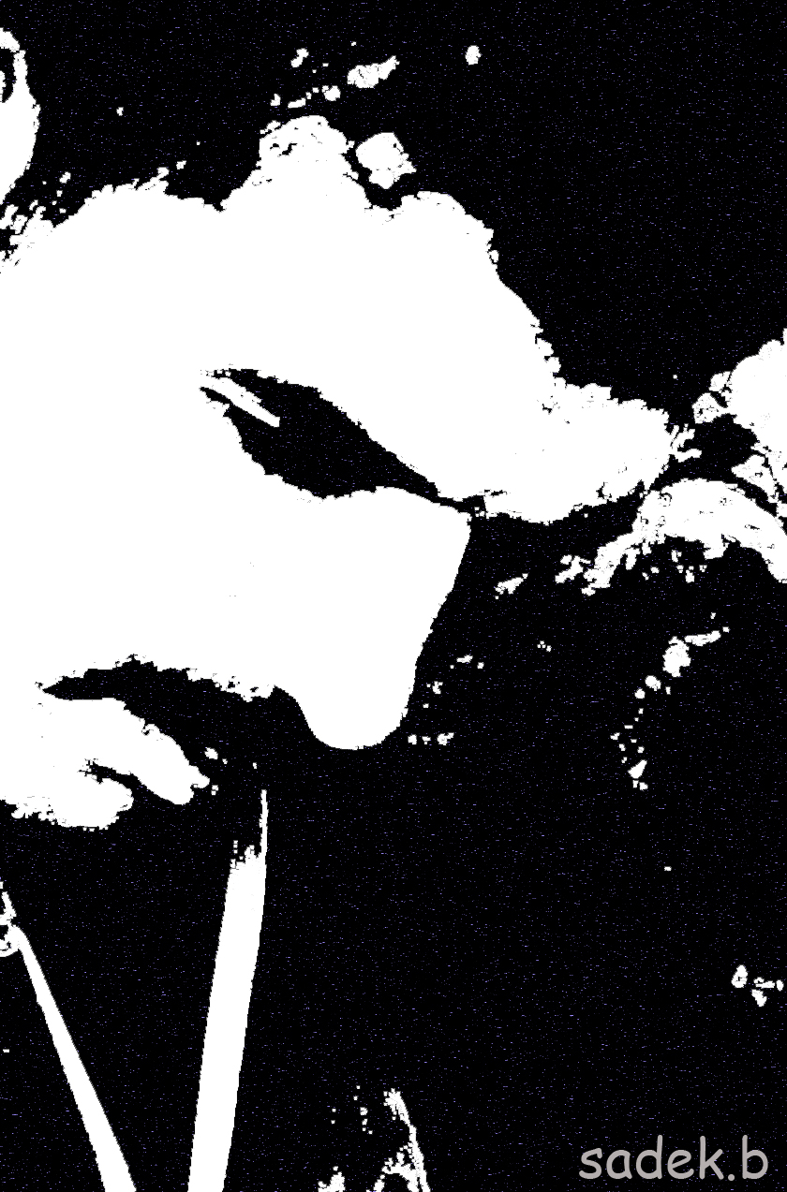
Sadek boudiar is a Self-made artist and graphic designer.
He has communications agency and publicity (Batoul Graphic& Design) in the Bir el- Ater Algeria.
Specialized design logos, He received a Grade Very Good Degree from the institute middle east of computer (Sharjah-UAE 2006),
and has participated in over 15 group shows in Algeria and Tunisia (signal in the dark -the international oasis festival of Tozeur-Tunisia)(Fine Arts Forum Tunisia 2013)

Festival City of Oued Souf Algeria 2013.

RomArt2015 15-18 May

Was summoned from more than ten countries, not shared because of his affiliations and concerns of life

He has lived in Algeria. His paintings are mostly Acrylic on canvas, Sand natural on wood,
and some oil on canvas and his signature work consists of sadness , spirit, black color.
He relied on the psychological and spiritual expressions have been any. And drawing things metaphysical -What you see the spirit -

When the man ascends become an artist
He lives painting and art in order to stay alive. Life is prayer of art.
Art is a son of religion.
The secret of happiness in grief.

Name: Boudiar
Given name: Saddek
Nationality: Algerian
Date of birth: 16-09-1981
Place of birth: Djebel-ONK Algeria
Gender: Male
Marital Status: married
Profession: Graphic Designer, Art-Mixt
Mobile: 00213 5 50 42 29 43
E-mail: Boudiars@yahoo.fr
Thanks a Lot My respect

