ARTIST BIOGRAPHY
Kerry Zacharia

Kerry Zacharia is a London born Artist with Greek-Cypriot origins. She displayed creative talents as early as the age of six, but for one reason or another her career took on a different path. However, her passion for art long remained and she is now back where she belongs!
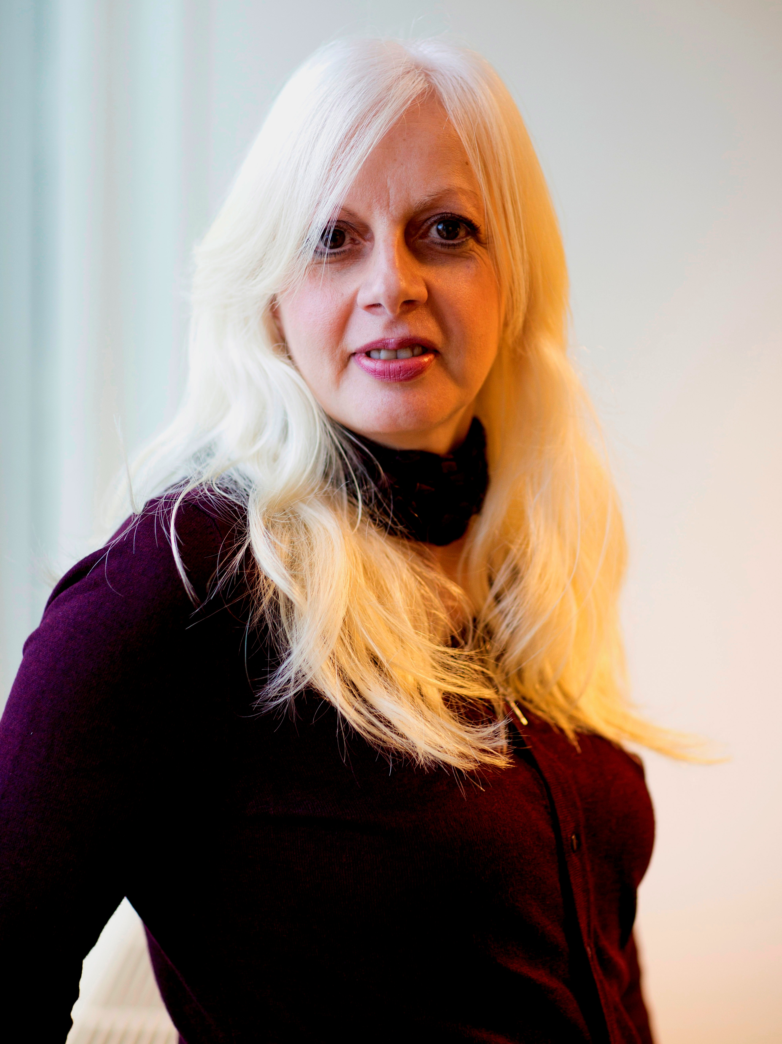
Kerry’s style is quite different as she uses lines, shapes, patterns and subtle tones to express her creative vision. The media used in her art process is ‘ink’ on paper.
She completed her first painting in this style in 2006, using red and black ink. At that time she felt a strong sense to express her vision from her depths of pain and sought to expose the layers of vulnerability. Her vision flowed out into the lines, patterns and shapes in abstract dimensions. Hidden within those lines was the figure of Kerry herself. Astounded by the outcome of her vision, she continued to produce a further six paintings in the red and black theme before launching herself as an 'Artist'. This unique ‘Red and Black’ collection will remain as her 'Private Collection' and it was indeed used for her launch.
Since October 2013, she has created a further four collections. Including six paintings in the ‘Inner City London’ theme; six paintings in the ‘London Landscapes’ theme; the ‘Mirror, Butterfly and Source’ Trilogy; and a set of four paintings in the ‘Taste of Europe’ theme. She tends to think and work in themes as it gives her the opportunity to explore different dimensions within the theme in a structured way, focussing her creativity. Kerry achieved her first sale from the ‘Inner City London’ Collection, ‘Mysterious by the Thames’ in April 2014.
Her official launch was at The Brick Lane Gallery in March 2014 in a group ‘works on paper’ show. She continued to exhibit throughout 2014 and was at 93 Feet East, Brick Lane with The Cult House in September and November 2014. She also took part in an international art fair with the Global Art Agency in Rotterdam in September 2014. This year she has started off with two prestigious exhibitions in January; ‘Art of Angel’ with Art Below and ‘ArtRooms2015’ with Art Rooms London represented by the Cult House. In February, Kerry also took part in the first Flux Exhibition, curated by Lisa Gray of Gray’s Art Gallery.
The feedback she has received from the public, other artists and exhibitors is astounding! Comments such as ‘your style is different’, ‘I can feel the energy’, ‘there is a lot of movement’, ‘not seen anything quite like these before’, ‘amazing’ are among those most heard. One outstanding comment received from the Flux exhibition was “…To me your work stands out in a class of its own... Your works respond to the urban scene in an expressive graphic style that is highly individual, yet addresses the viewer in a very decisive and engaging way…”
People are associating a likeness to Van Gogh in her art, although this is not intentional but complimentary of course. Kerry is self taught and thus without an art school education to influence her style.
Kerry also engages in supporting other artists and does not miss an opportunity to enhance the experience and knowledge of others, whilst she is also learning herself!
An abstract expressionist Artist with duality sums Kerry up! She expresses what she sees and experiences in her life, her ‘spirit’ art and from what she feels and creates from deep within, her ‘soul’ art. Being London based, this will always be a major influence in her art, however, inspiration from travels or through others will not go amiss.
Art is a large part of her heart and soul and as someone recently said to her “part of her DNA”.

www.artistkerryzacharia.com

