CV

Eleni Kyriazopoulou

painter

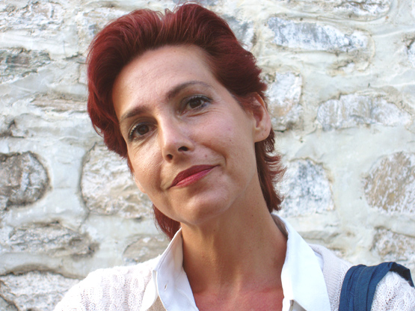
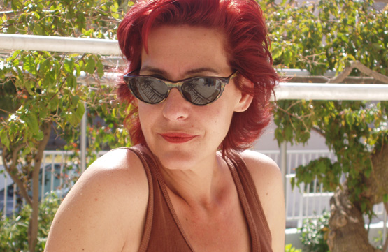

Eleni Kyriazopoulou was born and raised in Athens, Greece, where she has been working all her life. Ever since she was a little girl, she realized that playing with colors, observing forms and shapes, and painting them was a delight for her. Τhe procedure of painting was a window that connected her with the outside world, giving her joy and a sense of self-fulfillment.

As she grew up, she found some interest in French culture, and so she studied French literature at the University of Athens. She worked in various jobs that had nothing to do with her artistic aspirations, but helped pay the rent. In the year 2000, however, at the age of 40, she decided to take the risk and start painting as her sole occupation, quitting everything else that she had been doing till then. Self-taught at first, she soon started private lessons, in order to gain time in obtaining the technical know-how that would help her control her expressive means. For two years she studied with Yanna Persaki, and then another two years with Yannis Palaiologos, both well known Greek painters.

Her subjects, as she confessed in an interview for Greek television NET, are “exterior and interior landscapes, where one leans and rests one's soul. Landscapes that fulfill me, in contrast to figures that keep emptying...”

As soon as May 2003, when her first individual exhibition took place, her work was received very positively by both the public and certain art critics. One of them, named Harry Kampourides, who writes for a major Athens daily newspaper, was impressed by what he called “the vision of her soul”:
“ How many paintings retain our interest, when the eye is not satisfied by the surface and seeks the depth? Where does this secret light, shed on Kyriazopoulou's paintings, come from?
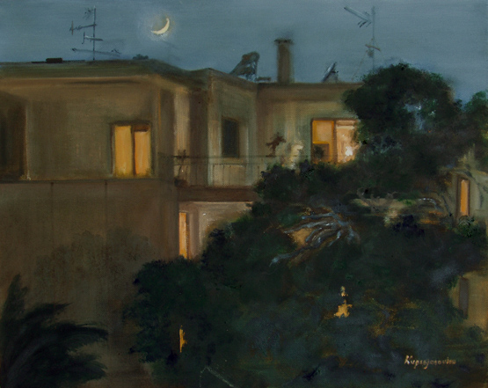
” [...] There is a melancholic atmosphere, based on a metaphysical peacefulness, but also on the anticipation of the unexpected. Many works contain a symbolic realism: on one hand, the viewer feels that the paintings are something like a conjectural diary, like a daily exercise of sentiments on favorite subjects. On the other hand, the shadow of a man whom we don't see, a woman suffocating in a corridor, the fence of a closed garden, all these compose the balance and the contrast between the tangible and the elusive, between daily routine and dreamy escapism”.
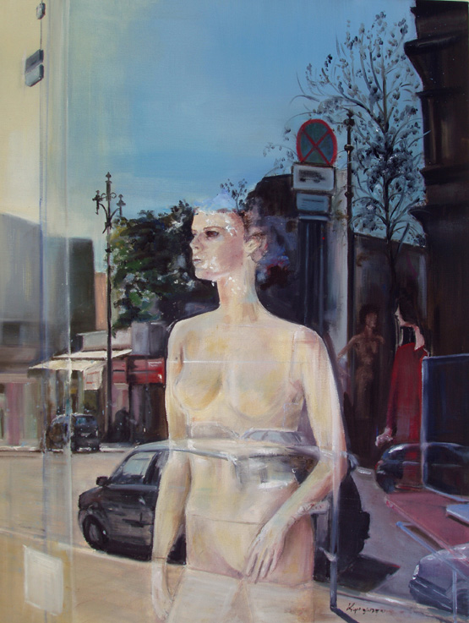
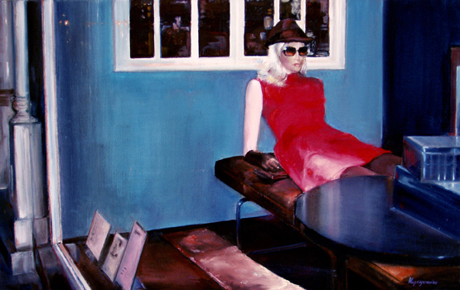
Since then she has made 8 individual exhibitions, and has participated in some group exhibitions, some of which took place abroad. She usually paints human figures wandering in somehow alienated environments, and for 3 years she worked in a series called “shop-windows”, depicting dressed mannequins, while reflections of cars and the streets outside give a feeling of loneliness and complexity to the scene.

She paints both oils and pastels. Her subject-matter reflects the variety of her state of mind, the atmosphere reflects her mood. When she works, nothing comes in between her and the painting. Art transforms in a continuous magical pursuit of bodies, objects, nature, whatever excites her interest and imagination.
Exhibitions:

Year / Mo. Place City
2003 / 05 Athens College Athens
2003 / 12 Bizart Gallery Athens
2004 / 07 Roides Hall Hermoupolis
2005 / 05 Psychari Gallery Athens
2005 / 12 Museum Gallery Thessaloniki
2007 / 04 Chryssothemis Athens
2008 / 09 Peri Technon Athens
2010 / 02 Alba Athens
2012 / 04 Black Duck Athens

