LUCREZIA TESTA IANNILLI

ART DIRECTOR

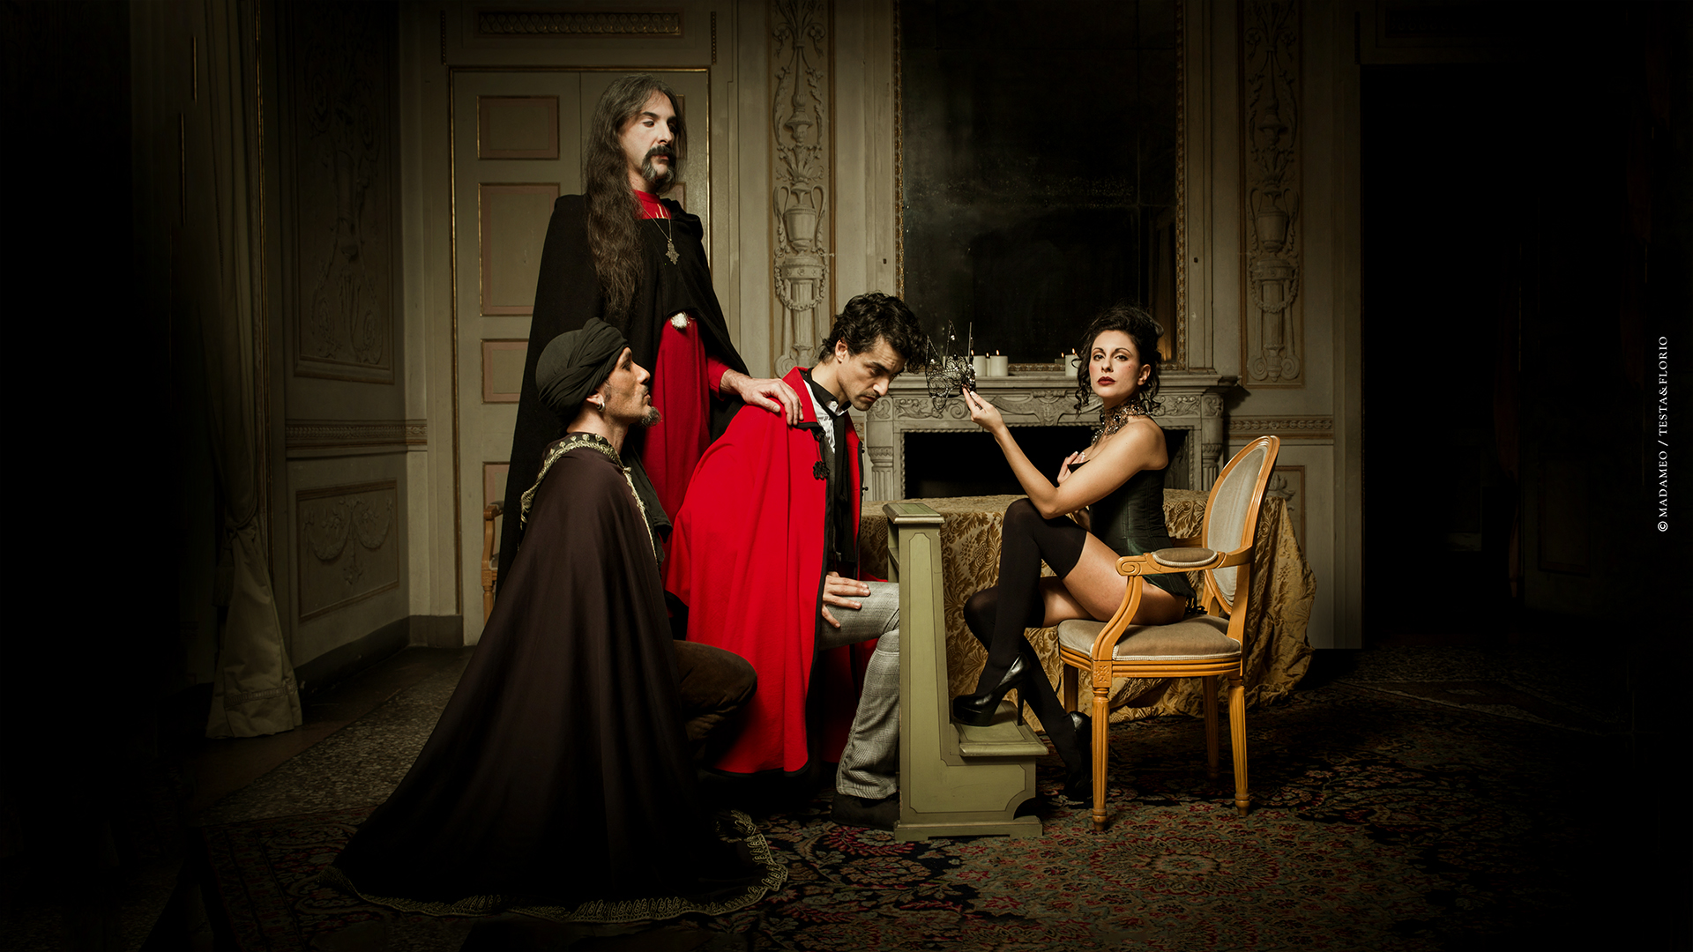

**REVELANT YOUNGEST EXPERIENCE**

**BULLE, Fribourg – SWISS 1994 (Oct/Dec)**

First successful restaurant managment experience in the renowned italian restaurant “Chez Angelo au Moleson” in Fribourg Swizerland.

|  |
| --- |
| **MONTREAL, - CANADA 1995 (Jan/July)**  Successfully graduated federal horse riding instructor / breeding  and training manager at the Federal Equestrian Academy of Quebec (FEC), Canada.  **VOGHERA/BELLUNO/SIENA/ROME, Italy 1995/1999**  Federal instructor, judge, brader, trainer, manager for theindustry in horsemanship and riding  competitions, for several renomates private stables.  **BELO HORIZONTE, Brasil 1999 (Apr/Dec)**Teather events manager for a communications & marketing |

agency as weel as responsible for the floor arrangement of the famous jazz Bar Cafe com Letras located in the Savassi area, one of the most vibrant club in the City centre of BH.

**ROME, ITALY 2001/2008**

* **(Jan/Dec 2001)** Manager e barman: responsible for the stock and waiting stuff in few pubs in the city center in Rome, names include “The Duke” in Pantheon, “Shamrock” in the

Colisseum and “Fiddler’s” at Piramide.

* **(Jan 2002/Jan 2003)** Manager: responsible for the stock storage, waiting staff, accounting, musicians, and floor plan in the summer space “Capannelle” of the renomate Restaurant

“No Stress Brasil”.

* **(Feb 2003/Mar 2005)** Co-Owner of the LUAL Ltd, an agency for intermediation and

comunication of art, music and management business.

* **(2006)** Course and succesfully exams for the Food and Beverage license,

in the Chamber of Commerce of Rome.

* **(Sep 2007/Dec 2009)** Co-Owner & Art Director of the BIUTI sas, an organic Tea Room and Library: responsible for the musical and cultural events management e art strategy, public relations service, musicians coordinations, food and tea stock.

**LONDON, UK 2009/2010**

* **(Mar/May 2009)** Dely and art shop responsible at the Famous italian chain

“Carluccio’s”, Spiatlfield Market.

* **(Jan/Sep 2009)** Chef assistant and responsible for the public relations stock in

the organic italian restaurant “Stori Dely” in the vibrant area of Brick Lane.

* **( Jan 2010/Dec 2011)** Owner e Art Director of the Milonga &Tango School,

“Milonga Bohemienne” in the heart of Hackney.

* **(Oct 2011/Jan 2012)** Responsible for website/social network/public relations and viral strategy of comunication of the tango dance company&school

“Milonga della Stazione” in Rome.

**PALERMO/MILAN/ROME/VENICE, ITALY 2011/2014**

**AGOUST 2011**

DIRECTION / MAQUEDA BLAZE VIDEO

<http://www.youtube.com/watch?v=QyB5cnXMCRg&feature=share>

<http://www.siciliaweek.it/index.php?option=com_k2&view=item&id=506:video-di-lucrezia-testa-iannilli&Itemid=28>

**NOVEMBER/DECEMBER 2011**

PRODUCTION & ART DIRECTION BOHEMIAN CIRCUS 1812 EVENT

<http://www.youtube.com/watch?v=syyhpDuX0v0>

<http://www.youtube.com/watch?v=H_Irmfd-p-Y&feature=related>

<http://www.facebook.com/events/211393745602257/>

**JANUARY 2012**

OFFICIAL OPENING VILLA BRUCSJ alcova/atelier

<http://www.facebook.com/pages/Villa-Brucsj/255604907858752>

<http://vimeo.com/38537990>

**JANUARY 2012**

GRABRIELLA GRASSO & FRIENDS CONCERT / OFFICINE ZO - CATANIA

<http://www.youtube.com/watch?v=musflpBa7gc>

**FEBRUARY 2012**

PROMOTION / COPYWRITING & ART DIRECTION CITY ASSEMBLY:

<http://allevents.in/Palermo/LA-RENAISSANCE----ASSEMBLEA-CITTADINA/127841274005833>

<http://www.facebook.com/events/127841274005833/>

**FEBRUARY 2012**

GUEST at DECADENZA EVENT / VENICE:

<http://vimeo.com/46024841> - official video.

<http://www.veneziatoday.it/eventi/discoteche/Decadenza-Party-al-Teatro-San-Gallo.html>

<http://www.facebook.com/media/set/?set=a.399548403392534.111767.210204075660302&type=1>

**MARCH 2012**

BODHRAN TEACHER at the school:

<http://www.labottegadellepercussioni.it/bottega/insegnanti/51>

**APRIL/MAY 2012** – VIRAL STRATEGY/COPYWRITING/ARTDIRECTION/PROMOTION

ALESSANDRO ALA CITY ELECTION at the Consiglio Comunale / Palermo:

<http://www.youtube.com/watch?v=DJAjxNearrM&feature=share>

**PRELUDIO D'ARTE. UN SABATO D'AUTORE Parte prima**

<http://www.youtube.com/watch?v=TAFuIW6rEPk&feature=share>

**PRELUDIO D'ARTE. UN SABATO ELETTRONICO parte seconda**

<http://www.youtube.com/watch?v=gK_hPpWPmV4&feature=share>

**PRELUDIO D'ARTE. UN SABATO D'AUTORE parte terza**

<http://www.youtube.com/watch?v=6lnRG8NC6TI&feature=share>

**PRELUDIO D'ARTE.. UN GIOVEDI D'AUTORE# parte 4**

**APRIL 2012**

MANAGEMENT and PERFORMANCE at:

L’UOMO DARGENTO vs IL GENIO DI PALERMO READING

**TEATRO GARIBALDI APERTO**

[**http://allevents.in/Palermo/238235876274287**](http://allevents.in/Palermo/238235876274287)

**APRIL/AGOUST 2012**

SOCIAL MEDIA and PUBLIC RELATION MANAGER

**TEATRO GARIBALDI APERTO GROUP**

[**http://teatrogaribaldiaperto.wordpress.com/**](http://teatrogaribaldiaperto.wordpress.com/)

[**http://www.facebook.com/groups/250281011737425/**](http://www.facebook.com/groups/250281011737425/)

**SEPTEMBER/DECEMBER 2012**

MANAGMENT/ART DIRECTION/PROMOTION

Boudoir Manouche / FIRST GIPSY JAZZ & SECRET CLUB

<http://www.facebook.com/BoudoirManouche?ref=hl>

<http://www.balarm.it/eventi/9262-boudoir-manouche.asp>

**SEP/DEC 2012**

ART DIRECTION AND PROMOTION

MOUSTACHE! EVENT

[**http://www.facebook.com/groups/537787782913079/**](http://www.facebook.com/groups/537787782913079/)

**MAY/JULY 2013-2014**

ARTD DIRECTION/MANAGMENT/COPYWRITING/PROMOTION

LUNA PARK+TIGERS IN THE CITY EVENTS

http://www.testaflorioagency.tumblr.com

THE BOHEMIAN GALLERY

http://www.facebook.com/groups/628875907147826/

THE LOTOS

http://www.[facebook.com/pages/The-Lotos/1394100487501079?fref=ts](https://www.facebook.com/pages/The-Lotos/1394100487501079?fref=ts)

M.O. SECRET SOCIETY & EVENTS | Milan. Ibiza. Venice. Rome.

https://www.facebook.com/pages/Lucrezia-Testa-Iannilli/550581721651921?fref=ts

**INDEX OF PLACES:**

- Bohemian Photografer Gallery – Palermo 2013/2014

- Boudoir Manouche – Palermo/Toulose 2012/2013

- Bohemian Circus – Palermo 2012 bohemiancircus.com

- Teatro Garibaldi Aperto – Palermo 2012 [teatrogaribaldiaperto.com](http://teatrogaribaldiaperto.com)

- Milonga della Stazione – Roma 2011 milongadellastazione.com

- Boys Tango Club – London 2010 hackneytango.com

- Rendez vous des Amì – Paris 2010

- Stori Dely – London 2009 storydeli.com

- Carluccio’s – London 2009 carluccios.com

- Strada – London 2009 strada.co.uk

- BiuTì sas – Rome 2007/2008 biuti.it

- Profumi di Sicilia – Rome 2006

- Lual srl – Rome 2003/2005

- No Stress Brasil – Rome 2002

- BlackD.Pub/Shamrock/Fiddler’s - Rome 2001 shamrockirishpub.it

- Cafè Com Letras – Belo Horizonte 1999 cafecomletras.com.br

- Academie Equestre Mont St Hilaire – Montreal 1995

- Chez Angelo au Moleson – Bulle 1994

**LANGUAGES:**

Iatalian (Mother Toungue)

French (Fluent)

Portuguese (Fluent)

English (Basic)

Spanish (Basic)

**PERSONAL DETAILS:**

Nationality: Italian

Date of Birth: 11/12/1977

Marital Status: Single

**INTERESTS:**

Photography, Historic and Charming Location, Music, Art, Interior Design, Public Relations, Literature, Antiques, Tango, D’essai Cinema, Subcultures, Food and Vine, Tea, Horse Riding & Polo, Theatre, Circus, Sicily, Body Building, Travel, Healty Life Style, Architecture, Dress Code Events, People.

**SOCIAL MEDIA**

**mail** | [lucreziatestaiannilli@gmail.com](mailto:lucreziatestaiannilli@gmail.com)

**website** | bohemiancircus.com

**linkedin** | [linkedin.com/profile/edit?trk=tab_pro](http://www.linkedin.com/profile/edit?trk=tab_pro)

**flickr |** flickr.com/photos/lucreziatestaiannilli

**facebook** | [facebook.com/lucrezia.iannilli](http://www.facebook.com/lucrezia.iannilli)

**twitter** | [twitter.com/#!/lucreziaTJ](https://twitter.com/#!/lucreziaTJ)

**tumblr** | bohemiancircus.tumblr.com

**pinterest** | pinterest.com/lucreziatj

**wordpress** | [lucreziatestaiannilli.wordpress.com/](http://lucreziatestaiannilli.wordpress.com/)

**stumbleupon** | stumbleupon.com/stumbler/bohemiancircus

**about.me** | about.me/lucreziatestaiannilli

**scoop** | [scoop.it/u/lucrezia-testa-iannilli](http://www.scoop.it/u/lucrezia-testa-iannilli)

**youtube** | youtube.com/user/lucreziatestaiannilli

|  |
| --- |
| **behance** | [behance.net/bohemiancircus](http://www.behance.net/bohemiancircus)  LUCREZIA TESTA IANNILLI  0039 | 349 8798964 Rome/Palermo  0044 | 779 4438539 London |

