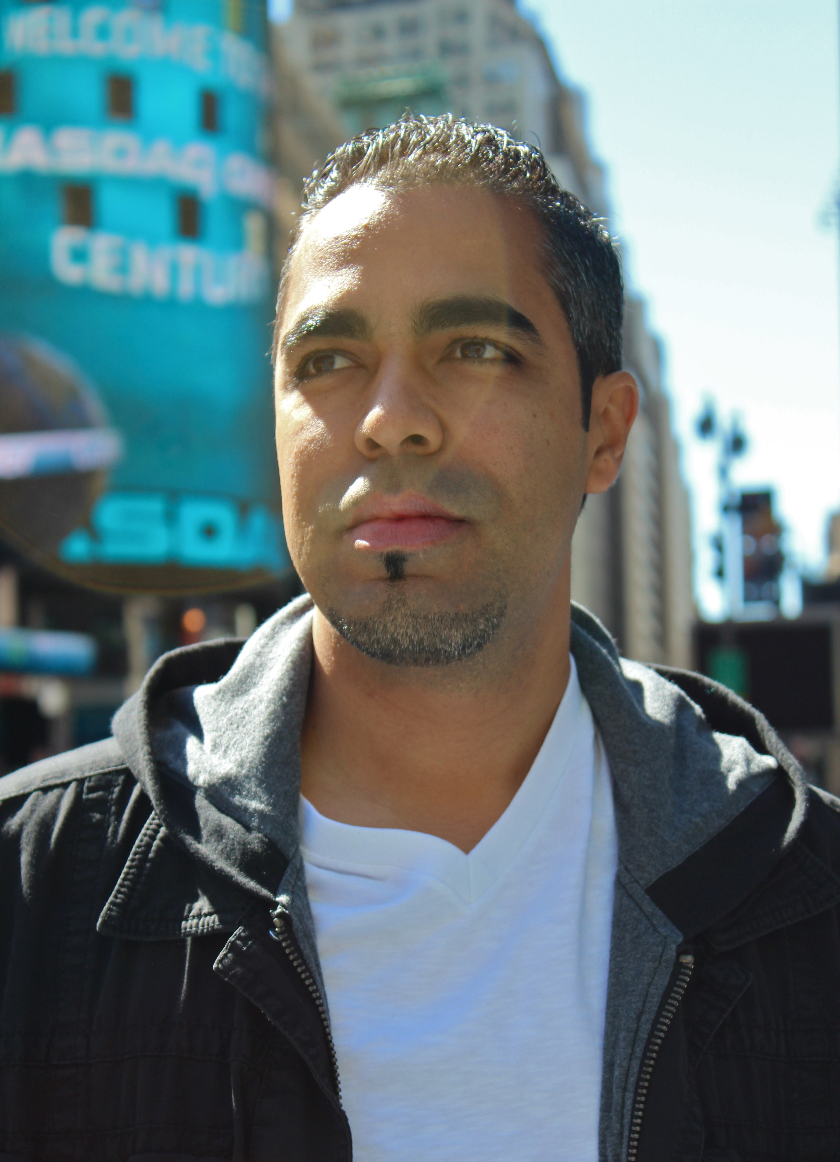**Julio Lugo Rivas (Ponce, Puerto Rico, 1978)**

**Biography**

Visual artist born in Ponce, Puerto Rico, in November 21, 1978. From an early age he presented a big inclination for art, music and sciences. At the age of fifteen he began his formal studies in art at the Escuela de Bellas Artes de Ponce where he obtained a strong basis in drawing, painting, etching and art appreciation to then give freedom to its disturbing creativity.

Later he began his university studies in the field of science, and in 1999 he finished a degree in Biology from the University of Puerto Rico at Mayaguez Campus.   
During this period he took art appreciation classes and at the same time, explored a new way to practice his art skills by making illustrative drawings of microorganisms for the Biology Laboratories. The utilization of the microscope in the investigations projects, captive his attention and gave start to his concern for expressing themes related to the “organic life” in his paintings. For the first time discovered the possibility of creating a link between their two greatest passions: the art and science.

At the age of 19, he decided to formalize his scientific interest in the field of pharmacy. Always exercising his profession of artist, he succeeded to push financially his his career through the participation in various solo and group exhibitions in Puerto Rico. In 2002 he obtained a Bachelor of Science in Pharmacy from the School of Pharmacy of the University of Puerto Rico, Medical Sciences Campus. His academic formation as a pharmacist brings new changes in his artistic proposal. New elements originating from the processes of illness and healing at a cell level turns his artistic investigation in a tireless search for the homeostasis that is translates in his painting as a search for balance and movement.

His passion for art and his interest in promoting the artistic movement of the southern area of Puerto Rico, motivated him to found in 2010 Platform 121, Inc., project of self-management that combines an artistic residency program and a platform of services that serve to support the development of new artistic proposals. Currently he is President of that institution and work full time his two careers, artist and pharmacist.

**Curriculum vitae**

**Julio Lugo Rivas (Ponce, Puerto Rico, 1978)**

lugo_rivas@Hotmail.com

www.juliolugorivas.com

**Education:**

2002      *Bachelor of Science in Pharmacy*, School of Pharmacy, Medical Science Campus. San

Juan, Puerto Rico.

1999      *Degree in Biology.* University of Puerto Rico, Mayagüez Campus.

1996   *Certification in Visual Arts*. School of Fine Arts of Ponce

Ponce, Puerto Rico.

**Continuing education:**

2009 Curatorial and educational museography in the 21st Century.

Roundtable discussion; resources: Cheryl Hartup (MAP), Arlette de la Serna (MAP), Jorge Figueroa (MHP)

Museo de Arte de Ponce, Ponce PR.

**Solo SHOWS:**

|  |  |
| --- | --- |
| 2013 Objetivo 20x  Centro Sociocultural El Soto, Madrid, España  2010 Cambios, transiciones y retornos  Galería Trinitaria, Ponce, PR.  2003 De Vuela al Microcosmos  West Gallery, Mayagüez, PR.  2001 Sub-sentidos, Galería OP  Hato Rey, PR.  1996 Evolución  Escuela de Bellas Artes de Ponce, Ponce, PR.  **Colective Show (selection)**  2013 Muestra Nacional de Arte  Antiguo Arsenal de Marina Española, San Juan, Puerto Rico.  2013 Bienal De Palermo  Museo Civico de Monreale, Italia.  2012 IDEARTE, Subasta internacional de Arte en Honduras  Museo para la Identidad Nacional (NIM), Tegucigalpa, Honduras.  2012 Aduana  Casa González Cúyar, Colégio de Arquitectos y Arquitectos Paisajistas de  Puerto Rico  2012 De lo Abstracto a lo figurativo  Galería Pamil, San Juan, PR.  **Awards**  2010 Lilly Oncology On Canvas  Primer Lugar, Categoría *Health Care Professional*  **Publications:**  **Book**  Lilly Oncology On Canvas: Expressions of a Cancer Journey,  Selections from the 2010 Art Competition and Exhibition, p 10, p 258.  **Magazines**  Rosario, Nilda. “Los mundos de cambio, transiciones y retornos”. Revista Plataforma 121 (Ponce Puerto Rico), año 1 núm. 1, abril de 2011, p. 11  Lugo, Julio. “Cambio, transiciones y retornos”. Revista Farmacia de Comunidad  Industria Farmacéutica de Puerto Rico. Vol. 4, núm. 8, marzo-mayo de 2010. pp. 52, 53  **Newspaper**   |  | | --- | | Pérez Ruiz, José Antonio, “De vuelta al cosmos”, El Vocero (San Juan, Puerto Rico), jueves 5 de junio de 2003, p. E 22 Escenario.  Pérez Rivera, Tatiana, “Apasionada Combinación”, El Nuevo Día (San Juan, Puerto Rico), jueves 8 de mayo de 2003, p. 6 Arte y Cultura.  Pérez Rivera, Tatiana, “Encuentro de rutas plásticas”, El Nuevo Día (San Juan, Puerto Rico), lunes 18 de noviembre de 2002, p. 74 Arte y Cultura.  **Volunteer work**  2010Assistant artist of educational workshop. Reopening of the Museo de Arte  de Ponce, Ponce Puerto Rico.  **Project**  2010 Founder and President of Platform 121, Inc. | |

**Artist statement**

*"Lugo belongs to this new generation of artists that show the possibility of seeing and understanding the world (the large and the small) and his environment, and at the same time establishes a communication between both." With his work, Julio Lugo seeks reconciliation, an intimate relationship between the artistic and the scientific world. Lugo seems to use a scientific method as a structure to paint the abstractions of the physical/philosophical life. You could say that in Lugo you have two very different people, with one uniting element: Nature.*

*William Taylor Suderman, art critic, 2002*

My artwork contains influences from surrealist art and currents of the organic abstraction, using as basis my background knowledge in science. Every work I do is result of a tireless search for represent organic life process and its relationship with its energy environment. My interest to integrated science in my artistic proposal led me to establish a symbiotic relationship between the scientific knowledge gained through my training in the field of science and my artistic research. I use mixed media (acrylic and graphite) to recreate, thru principles of balance and movement, a synthesis of the behavior of nature.

A visual overview of the work invites us to decipher a continuous conversation of symbols, forms and situations between two worlds: the scientific and the artistic. The message of my work is transmitted to the viewer through an organic language, where the main character, the cell, tells stories of his journey through the microscopic universe. This element is revealed not only as the basic unit of life, if not as the unifying center of the entire image. In this way becomes, the cell, the universal icon of life in my artwork. However, despite its leading role, the importance of this character in my work do not comes from his intrinsic identity, if not from the different situation occurring in its environment. Thus, the dialogue between all the elements in the composition becomes the main attraction of the artwork. The image becomes sense when the viewer realizes the similarity between the microscopic and the macroscopic world. With each piece we can concluded that the complexity and majesty of life manifests itself in a similar manner in all levels of the matter. Thus this way I integrate the spectator to make part of my artistic research, to submit with each creation, an instant of the microscopic universe and different ways of interpretation. Communication, interaction, balance, movement and energy describe and transform my work into a live image.

Julio Lugo Rivas, Visual artist