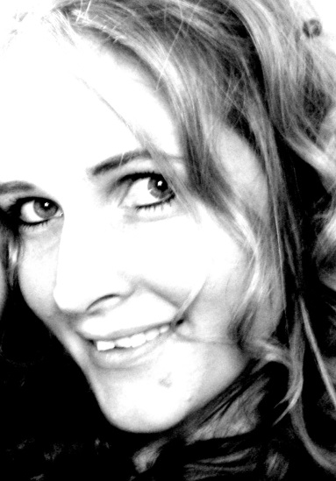

**Artistic step**

***“When the intensity of the colors and the delicacy of the female universe meet…”***

Abstract art but carried by the symbolic world, her artworks deal with of the exploration of the human conscience, our roots, our inner world.

The curves and flights bring release to the spirit and structure to the reason.

The materials defy the smooth vision of the reason to give access to the rough and mysterious intensity of the heart.

Most of the time, she also proposes a multiplication of the artistic directions by adding in her paintings some texts, words or various incrustations.

Her wish is to exceed the borders of a single art to reach an unconditional freedom and comprehension of the senses.

***Contact and visibility:***

- Internet site

<http://www.virginiecardinael.com/>

[virginiecardinael@yahoo.fr](mailto:virginiecardinael@yahoo.fr)

Sentier du Bois, 1

4260-Braives

BELGIUM

0485/47.07.36

**Press :**

**Newspaper Vers l’Avenir : “*From Braives to London: the painting as a passport”***

**http://www.lavenir.net/article/detail.aspx?articleid=DMF20121020_00221065&fb_action_ids=10151122717412914&fb_action_types=og.recommends&fb_source=aggregation&fb_aggregation_id=288381481237582**

**Artistic course**

* **October 2010**

Art à Nu(Hannut)

* **November 2010**

Artistes d’ici et d’ailleurs (Fléron)

* **February 2011**

ClairObscur gallery (Liege)

* **March 5, 2011**

Course of Artists, the Woman’s day (Huy)

* **May 27 to June 26, 2011**

Gallery “To the Wire of Water” (Fumal, Liege)

* **June 1 to November 1, 2011**

Permanent exposure Act 2 Inside Home Interior (Welkenraedt)

* **6 August 21, 2011**

Art Gallery Christie, Holiday artistic event (Soiron)

* **September 2011**

Artistic contest: “Soiron, the most beautiful village of Wallonia”

* **October 2011-October 2012**

One year partnership with the Gallery Arteconte (Paris St Germain des Pres)

* **5 November 20, 2011**

Solo eshibition Art Gallery Christie (Soiron)

* **December 4, 2011**

Winter artistic event `Feelings' (Art centre of Ottignie)

* **13 January 27, 2012**

Solo exhibition Gallery Arteconte (Paris St Germain des Pres)

* **February 2012:**

Collective exhibition Gallery Arteconte (Paris St Germain des Pres)

* **February 2012**

Solo exhibition gallery ArtKange (Embourg)

* **April 26 to May 6, 2012**

Solo exhibition Gallery Art without Suit (Brussels)

* **May 6 - at the end of July 2012**

Collective exhibition to art festival of the Lavaux Saint Anne castle

* **May 3, 2012**

Collective exhbition Gallery Arteconte (Paris St germain des Pres)

* **26- May 28, 2012**

Collective exhibition `the 5 senses' (Soiron)

* **12 July 19, 2012**

Collective exhibition Gallery Arteconte (Paris)

* **20 July 22, 2012**

Exhibition to the artistic event “the farm of the artists” of Sarts (gallery Christie)

* **25- August 26, 2012**

Ballades Braivoises.

* **September 22 to October 28**

Solo exhibition Gallery Art'mony (Liege)

* **12 October 14, 2012**

Parralax Art Fair (London, Chelsea, England)

* **8 December 23, 2012**

Solo exhibition International Cobalt Gallery (Brussels)

* **March - August 2013**

Exhibition gallery Böehner (Mannheim, Germany)

* **April 27, 2013**

Exhibition Barcelona showcase GAA in Batllo House (Spain)

* **May 2013**

Exhibition Hilton Hotel London

* **April 27, 2013**

Exhibition Hilton Hotel Stockholm

* **May 2014**

Solo exhibition Art Christie Gallery (Soiron)