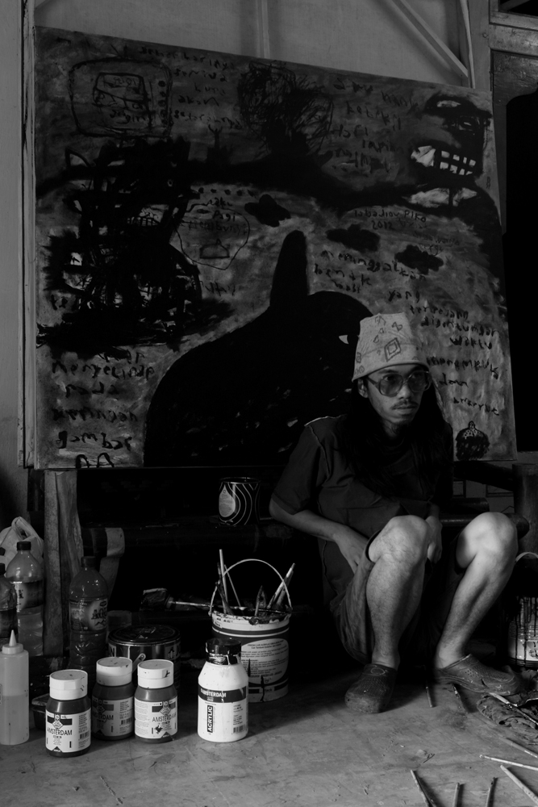
IABADIOU PIKO
ARTIST NAME : Iabadiou Piko
PASSPORT NAME : Piko Sugianto
BORN : Prabumulih June 10, 1984 South Sumatera.
SEX : Male
AGE : 28 Years
EDUCATION : Three Years Post Graduate Diplom of Art
Photography Design ( ADVY )
Yogyakarta 2002 – 2005 Indonesia.
STUDIO ADDRESS : Keloran Rt. 08 ( SOR SAWO ) Dukuh IV
Plurugan Tirtonirmolo Kasihan Bantul
Yogyakarta 55181 Indonesia
MARITAL STATUS : Single
NATIONALITY : Indonesia.
E-MAIL : iabadioupiko@gmail.com
SITE : www.iabadioupiko.wordpress.com
MOBILE PHONE : +62 ( 0 ) 8132 888 4009

ACTIVITIES

AWARD

2013

- New Masters Public Top 100 Artists 2012 Competition Netherlands.
- Finalist Shortlisted Candidates International Emerging Artist Award Dubai 2012 - 2013 2nd Edition ( IEAA ). Jury by Patricia Millns, Carole Rinaldi, Julie De Waroquier, Olivier Henry, Kerimcan Guleryuz, Didier Gourvennec Ogor.

2012
- Osten Award “The 40th World Gallery of Drawing, Osten Biennial of Drawing”, Skopje Macedonia 2012. Jury by Pavle Pejovic MA, Montenegro, Dr. Barnaby Wright, Great Britain, Nickolas Thaw, USA.
- Finalist The 5th Beijing International Art Biennale, China 2012 Exhibition The National Art Museum of China, Beijing, China. Chief Curator by Liu Dawei, Feng Yuan, Wang Mingming, Wu Changjiang. International Curator by Gustafsson Roger.

2011
- Finalist The third Bangkok Triennale International Print and Drawing Exhibition by Silpakorn University Thailand. Initial Screening Jury Members by Prof. Emeritus Prayat Pongdam, Prof. Decha Warashoon, Prof. Ithipol Thangchalok, Prof. Preecha Thaothong, Assoc. Prof. Pishnu Supanimit, Assoc. Prof. Parinya Tantisuk, Asst. Prof. Thavorn Ko-undomvit, Mr. Amarit Chusuwan, Asst. Prof. Yanawit Kunchaethong. Final Screening Jury Members by Prof. Emeritus Chalood Nimsamer, Prof. Keisei Kobayasi, Prof. Liz Ingram, Prof. Ithipol Thangchalok, Asst. Prof. Thavorn Ko-undomvit.

2009
- General Prize Winners of the 2009 FRESH M.I.L.K. PHOTOGRAPHIC Competition Parnell, Auckland, New Zealand.

SELECTED GROUP EXHIBITION

2013

- Dunia Ketiga Orang Ketiga at Taman Budaya Padang West Sumatera. Curator by Anton Rais Makoginta.

- The 4x6/6x4 Postcard Charity Exhibit at the University Center Art Gallery, Colorado Mesa University.

- The 3rd Bangkok Triennale International Print and Drawing Exhibition to celebrate on the auspicious occasion of His Majesty the King’s 7 th Cycle Birthday Anniversary 5 th December 2011 at Sanamchandra Art Gallery, Silpakorn University, Sanamchandra Palace Campus, Nakhon Pathom province. Bangkok, Thailand. Writer by Mr. Chai Nakhonchai, Mrs. Prisna Pongtadsirikul, and Lukana Kunavichayanont.

2012
- “The 40th World Gallery of Drawing, Osten Biennial of Drawing”, Skopje Macedonia 2012. Writer by Pavle Pejovic.
- Overnight Sensation at Lotte Gallery Korea. Curator by Kwon Yoon – Kyung.
- “ Membunuh Kemenangan “ with Barrack Art at PKKH ( eks Purna Budaya Gajah Mada University ) Yogyakarta Indonesia. Curator by Anton Rais Makoginta, Writer by Prof. Dr. Faruk HT.S.U. and Rain Rosidi.
- The 5th Beijing International Art Biennale, China 2012 Exhibition at The National Art Museum of China, Beijing, China. Chief Curator by Liu Dawei, Feng Yuan, Wang Mingming, Wu Changjiang. International Curator by Gustafsson Roger.
- Mari Boeng....!!!! Caring the Spirit with Our Freedom with Barrack Art at Pekan Apresiasi Benteng Vredeburg Museum Yogyakarta. Curator by Anton Rais Makoginta.
- Charity Exhibition “ Cambridge UK of Europe’s First Eco - Mosque!” at Cambridge University UK.
- The 3rd Bangkok Triennale International Print and Drawing Exhibition to celebrate on the auspicious occasion of His Majesty the King’s 7 th Cycle Birthday Anniversary 5 th December 2011 at Bangkok Art and Culture Center, Pathumwan District, Bangkok, Thailand. Writer by Mr. Chai Nakhonchai, Mrs. Prisna Pongtadsirikul, and Lukana Kunavichayanont.
- Festival Seni Rupa “ Negari Ngayogyakarta Hadiningrat HB IX 100 th “ at Jogja National Museum. Curator by Prof. Drs. M. Dwi Maryanto, MFA, Phd.
- Different Taste at KOI Kemang Restaurants and Gallery Jakarta.
- The 14 th Annual Postcards From the Edge A Benefit for Visual AIDS at Cheim & Read Gallery New York.

2011
- Preview Warwick Gallery ( Tembi Gallery ) Yogyakarta .
- Drawing Connections Exhibition Siena Art Institute Siena Italy .
- SEA Games XXVI 2011 at Arya Duta Palembang .
- Personal Oikumene by Ketjil Bergerak at Kersan Art Studio Yogyakarta. Curator by Sarah Vandepeer and Idha Saraswati.

2010
- Charity Exhibition “ Jogja Gumregah! Jogja Bangkit!” at Jogja National Museum Yogyakarta.
- 6x6 You Asked For It. Rochester Contemporary Art Center New York.
- Neo Spirit at Biasa Gallery Yogyakarta.
- Door 2 Door, Therapy ( Bendera Community ) at Jogja International Hospital Yogyakarta.

2009
- Golden Box #3 at Jogja Gallery Yogyakarta.
- Selayang Pandang Bumi Sriwijaya # II at Taman Budaya Yogyakarta.
- Pesta Topeng Monyet at Balai Sriwijaya alternative art space Yogyakarta.

2008
- It’s Not Easy ( Green ) Photography at Exit Art Gallery New York.
- Photo Expo C4C at Rumah Seni Yaitu Semarang.
- Photo Expo C4C at ADVY Gallery Yogyakarta.
- Photo Expo C4C at Balai Soedjatmoko Solo.

COLLECTION

2012

- “The 40th World Gallery of Drawing, Osten Biennial of Drawing”, Skopje Macedonia 2012
ARTIST STATEMENT

I’m an artist from Prabumulih, South Sumatera, Indonesia. I studied at Academic Design of Vision Yogyakarta Department ( ADVY ), Three Years Post Graduate in Diploma of Art Photography Design in 2005. I live and work in Yogyakarta. I have participated in selected group exhibition in Yogyakarta, Semarang, Solo, Padang, and Jakarta Indonesia. My work has also been included in group shows at Cheim & Read Gallery, New York, Siena Art Institute Siena Italy, The 3rd international print and drawing exhibition at Bangkok Art and Culture Center Thailand, The Fifth Beijing International Art Biennale, China 2012 Exhibition at The National Art Museum of China, Beijing, China, “The 40th World Gallery of Drawing, Osten Biennial of Drawing”, Skopje Macedonia 2012, Overnight Sensation at Lotte Gallery Korea, and 4x6/6x4 Postcard Exhibit at Art Gallery The University Center, Colorado Mesa University USA.

My work portrays the memories in my daily life in an abstract and poetic atmosphere. I create my work using the medium of Painting and Photography. My work is abstract and intuitive, inspired by people I meet each day, things that happen to me, and places I have been. I capture memories, feelings and my imagination as my visual diary. My work is an allegory and metaphor of what goes around my life.

