**rutesantos_arts@netcabo.pt** 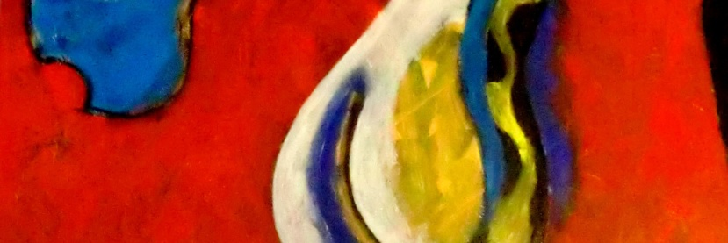

[**www.rutesantosgallery.com**](http://www.rutesantosgallery.com)

Rute Santos

**Visual Artist Resume**

**Education**

National Society of Fine Arts (Lisbon, Portugal)

&

IADE- Institute Visual Arts, Design and Marketing, Lisbon

Painting and Drawing

**Bio**

Born in 1977, in Setubal, Portugal.

Finished her studies at SNBA- Sociedade Nacional Belas Artes (National Society of Fine Arts)in Painting, in 2001, and in that same year started to exhibit her work solo.Then in Group.

Now with only 10 years on career, has exhibitions made in Portugal, Spain, and Italy.

My work is certified by the AIAP- Association Internationale des Artes Plastiques , by the National Committee, by UNESCO.

My work is represented in:

Public and Private Collections In Portugal,

Private collections in Spain, Portugal, England, U.S.A, Germany,

**Exhibitions - Selection**

* **“Graffi”** – International Group Exhibition - Studio Iroko ( Art Gallery) – **Milan, Italy**
* **Vive-Arte- International Exhibition of Contemporary Art** - Art Gallery Taller Maria Nieves – **Badajoz, Spain**
* **XVI International Exhibition of Visual Arts** – At Cultural center of **Vendas Novas, Portugal**
* **“Contemporary  Expressions”** - Club Financero de Vigo , Art Gallery– **Vigo, Spain**
* **National Exhibitin of Fine Arts** - Museum Mae d´Agua - **Lisbon, Portugal**
* **“Salty blue” – Group Exhibitions Fine Arts** - Cultural Center Nazaré – **Nazaré, Portugal**
* **“Eleven ways to be” at -** Art Gallery 4Montras – **Viseu, Portugal**
* **ART  PORTUGAL -**Gest´Arte Art Gallery - Lisbon – Portugal
* **X International Exhibition of fine arts** at Vendas Novas´s Cultural center, **Vendas novas, Portugal**
* **“ 5 Projects” - Painting Exhibition** – Gallery -Museum Carnide, **Lisbon-Portugal**
* **Biennial for Young Artists** at Capitel Art Gallery, **Leiria, Portugal**
* **Rute Santos & António Capella- Painting Exhibition** Municipal Library Art Gallery – **Barreiro, Portugal**
* **Solo Exhibition,** Art Gallery Painter Samora Barros, **Albufeira – Portugal**
* **Rute Santos - Solo Exhibition** at Art Gallery Cascais – **Cascais , Portugal**
* **“Network of Artists” – 5th Group Exhibition of Painting** , Novotel Art Gallery – **Lisbon, Portugal**
* **“Parallel visons”  - Group Arts Exhibition**, Espaço Lisboa , SpacioCenter, **Lisbon, Portugal**
* **“Arte em Belém”- Solo Exhibition**  at Art Gallery St. Mary Of Belem –**Lisbon , Portugal**
* **Grand Exhibition of Fine Arts** , Art Gallery Club Tap Air Portugal, **Lisbon, Portugal**

# Member of Art Organizations

AIAP- Association Internationale des Artes Plastiques (Europe)

ART PORTUGAL - Portuguese visual artists Group (Portugal)

AIBACC - International Associació of Barcelona d´Art i Culture Contemporary (Barcelona)

Association Friendship of the Arts Galician Portuguese. (Portugal)

Associazione Culturale ART GALLERY ( Milan, Italy)

Curated by: Barbara Vincenzo,

Francisco Urbano,

Conceição Ruivo

Maria Nieves

Mário Botas

Geni Settanni

António Sem