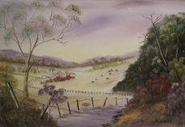 Artist CV. Debra Lohrere 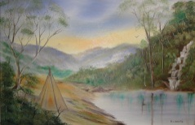

Debra Lohrere is an award winning Australian artist. She was born in Warragul Victoria, Australia in 1962 and spent most of her life in suburbs south east of Melbourne then moved to Queensland in 2004. She has been painting for over 30 years and her paintings hang in collections around Australia. She is a member of the Ipswich Art Society.

As a teenager she studied at the Alexander Art Gallery under Marlene Leary and Aubrey Hinchcliffe. She is inspired by contemporary Australian artists Kevin Best, Robert Hagan and her good friend, Host of TV Show “Art Studio”, Wayne Clements.

Her works vary in subject matter and colour. Her object as an artist is to communicate the emotional reactions that she feels in response to the scenes she is capturing. She wants to portray the wonder, awe or pleasure that she feels as she observes and responds to the beauty of nature. Debra loves to show colour and contrast in her subject matter. She works in both the impressionist and abstract genres. Her main aim is to capture Australia on canvas as she sees it through her eyes as an artist.

**Awards**

Honour Certificate Dandenong Youth Art Show 1978

First Prize Jimboomba Quota Art Show 2010

Third Prize (Portraiture) Greenbank Show 2010

**Exhibition History**

Jimboomba Quota Art Show 2010

Greenbank Show 2010

Rotary Spectacular 2010 (Finalist)

Royal Queensland Art Society Show 2010

EKKA 2010

RAS National Open Art Awards 2010 (Finalist)

Maryborough Art Festival 2010

Malaney Art Awards 2010

Ipswich Show 2010

2010 Ipswich Art Awards

Aspects Art Show 2010

Captain Cook 1770 Festival Art Show 2010

Sarina Art Extravaganza 2010

Brookfield Art Show 2010

Lenton Art Exhibition 2010

Jimboomba Quota Art Show 2011

Aspects Art Show 2011

Brookfield Art Show 2011

QT Ipswich Art Show 2011

Captain Cook 1770 Festival Art Show 2011

Woolam Waltzing Matilda Outback Art Show 2011 (Finalist)