CURRICULUM VITAE

Pantea Rahmani

Date & place of birth:
September 10. 1971. Tehran, Iran

E - mail: pantea_rahmani@yahoo.fr

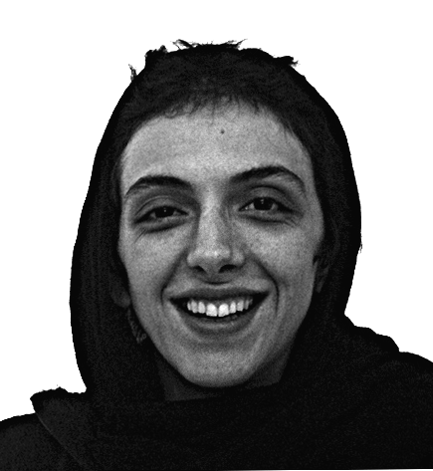

EDUCATIONS

1994 - 99 Art University, Fine Art Department, Tehran, Iran
(BFA) with Honours. Diploma: Painter, concentration in Painting and Drawing.

SOLO EXHIBITIONS

1999 Barg Gallery, Tehran, Iran
"Portraits"
2002 Barg Gallery, Tehran, Iran
"Whites"
2004 Elaheh Gallery, Tehran, Iran
"Cities & Towns"
2006 Mah Gallery, Tehran, Iran
"Demons"
2006 Hungarian Sculptor’s Association

2009 Gallery b21, Dubai, UAE
"Exposed"

SELECTED GROUP EXHIBITIONS

1996 University of Arts & Design, Kyoto, Japan
2000 Museum of Contemporary Arts, Tehran, Iran
Tehran 1st drawing biennale
Museum of Contemporary Arts, Tehran, Iran
Tehran 5th painting biennale

2003 Approaching Art Association, Pécs, Hungary
Museum of Contemporary Arts, Tehran, Iran
Tehran 6th painting biennale ; White series of oil painting.
Decourtney Gallery, Mons, Belgium
Léspace CROQU Árt, Brussel, Belgium

2004 Csepel Gallery, Budapest, Hungary
House of Arts, Szekszárd, (H)
Kaposfüredi Gallery and Sculpturepark, Kaposfüred, (H)
Kék Iskola Gallery, Budapest, (H)
5th Biennial of Fine & Applied Artists of Csepel, Csepel Gallery, Budapest, (H)
2005 15th Hungarian Medallion Biennial, Sopron, (H)
Museu da Água, Lisboa, Portugal
Palácio da Bolsa, Porto, Portugal

