***Viv King***

|  |
| --- |
| Contact details  Phone : 021 6894814  Cel : 071 032 3965  Email : [vk1@imaginet.co.za](mailto:vk1@imaginet.co.za)  Website : www.capeartscapes.co.za |

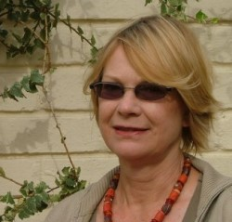

…………………………………………….

Viv has had no formal art training but has drawn and painted since childhood. In 1993 she took up painting with ***Wendy Martell*** at the ***Ruth Prowse School of Art***. Since then she has studied life drawing and abstract painting with ***Jill Trappler and John Cowan***. More recently she has studied landscape painting in Oils with ***Julia Teale***. She participated in the Tupelo workshop project at the National Gallery in Cape Town, South Africa and has participated in numerous group classes and workshops at the Frank Joubert art school in Claremont and ***the South African Society of Artists,*** (***SASA***), where she served on the Committee in 2008.

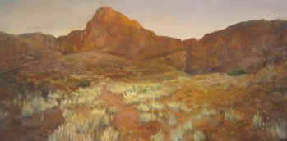 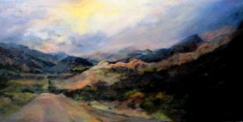

Fossilised Dunes, Sossusvlei: Oil/canvas Karoo Storm: Oil/canvas

1020 x 500mm 1020 x 500mm

She had her first solo exhibition at the ***Grahamstown National Arts Festival*** in 1997 when her poster won 2nd prize in the Poster competition. Since then she has had work exhibited at the ***Association of Visual Arts*** in Cape Town and the ***Bellville Library***, and has been represented by Art Galleries such as the ***Cape Gallery, Veo Gallery, Gil Alderman Gallery*** and ***Studio Art.***

Her painting, “***Fossilised dunes, Sossusvlei, Namibia*** (above left), earned a Commended award in the SASA 2010 selected annual exhibition.

Her current theme on exhibition is “Trees of Kirstenbosch and Cape Town” , which she interprets through the medium of Reverse painting on Perspex.

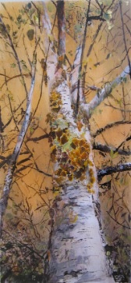 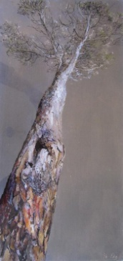 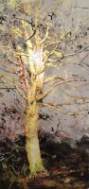

Birch tree in Autumn Last Stone pine standing Wild olive

Reverse painting on Perspex Reverse painting on Perspex Reverse painting on erspex

**“I am constantly amazed at the beauty of nature, which is my primary inspiration. A line from a Dylan Thomas poem so aptly expresses it –….. “the force that through the green fuse drives the flower”….. is what I hope to capture on canvas, and I would like to spend the rest of my life exploring, experiencing and expressing that force and the many forms it takes. Thank you for looking at my work.”**