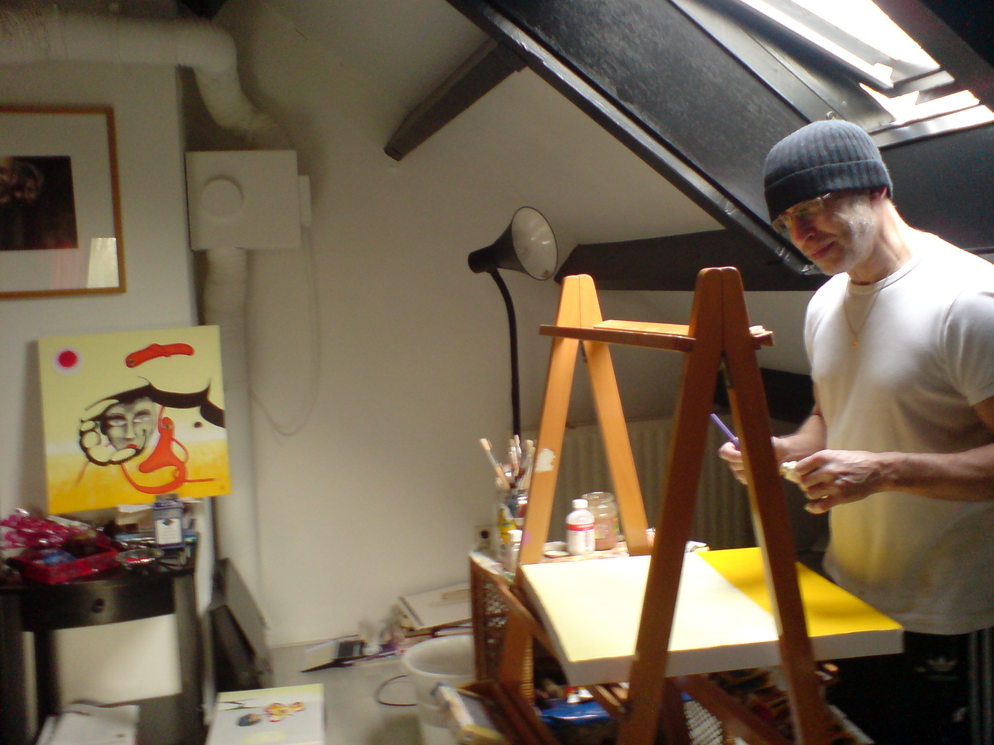
Mark Pol at work in his studio in Amsterdam
Mark Pol, Dutch Surrealistic artist
Mark Pol, born 17th October 1941 in The Hague has found an early passion for painting. His interest in drawing and painting started in primary school. And later on he went to the Photo Academy followed by the Free Academy led by George Lampe.
The work of Mark Pol, also shown on his website (www.markpol.nl), is in essence inspired by daily human life, without losing its vulnerability and the animal unpredictability. Despite the timeframe the painting or drawing might seem to be in, humanity is key in his work.
In the early stage of a painting, Mark Pol draws his thoughts and dreams with a pencil and then continues his vision with a basis of oil - or acryl paint on canvas. The expression of Mark Pol are often too much for the two dimensional canvas and the result is a three dimensional world, shown in different materials.
Website Mark Pol: www.markpol.nl
Mobile: 0031 6 45410400

