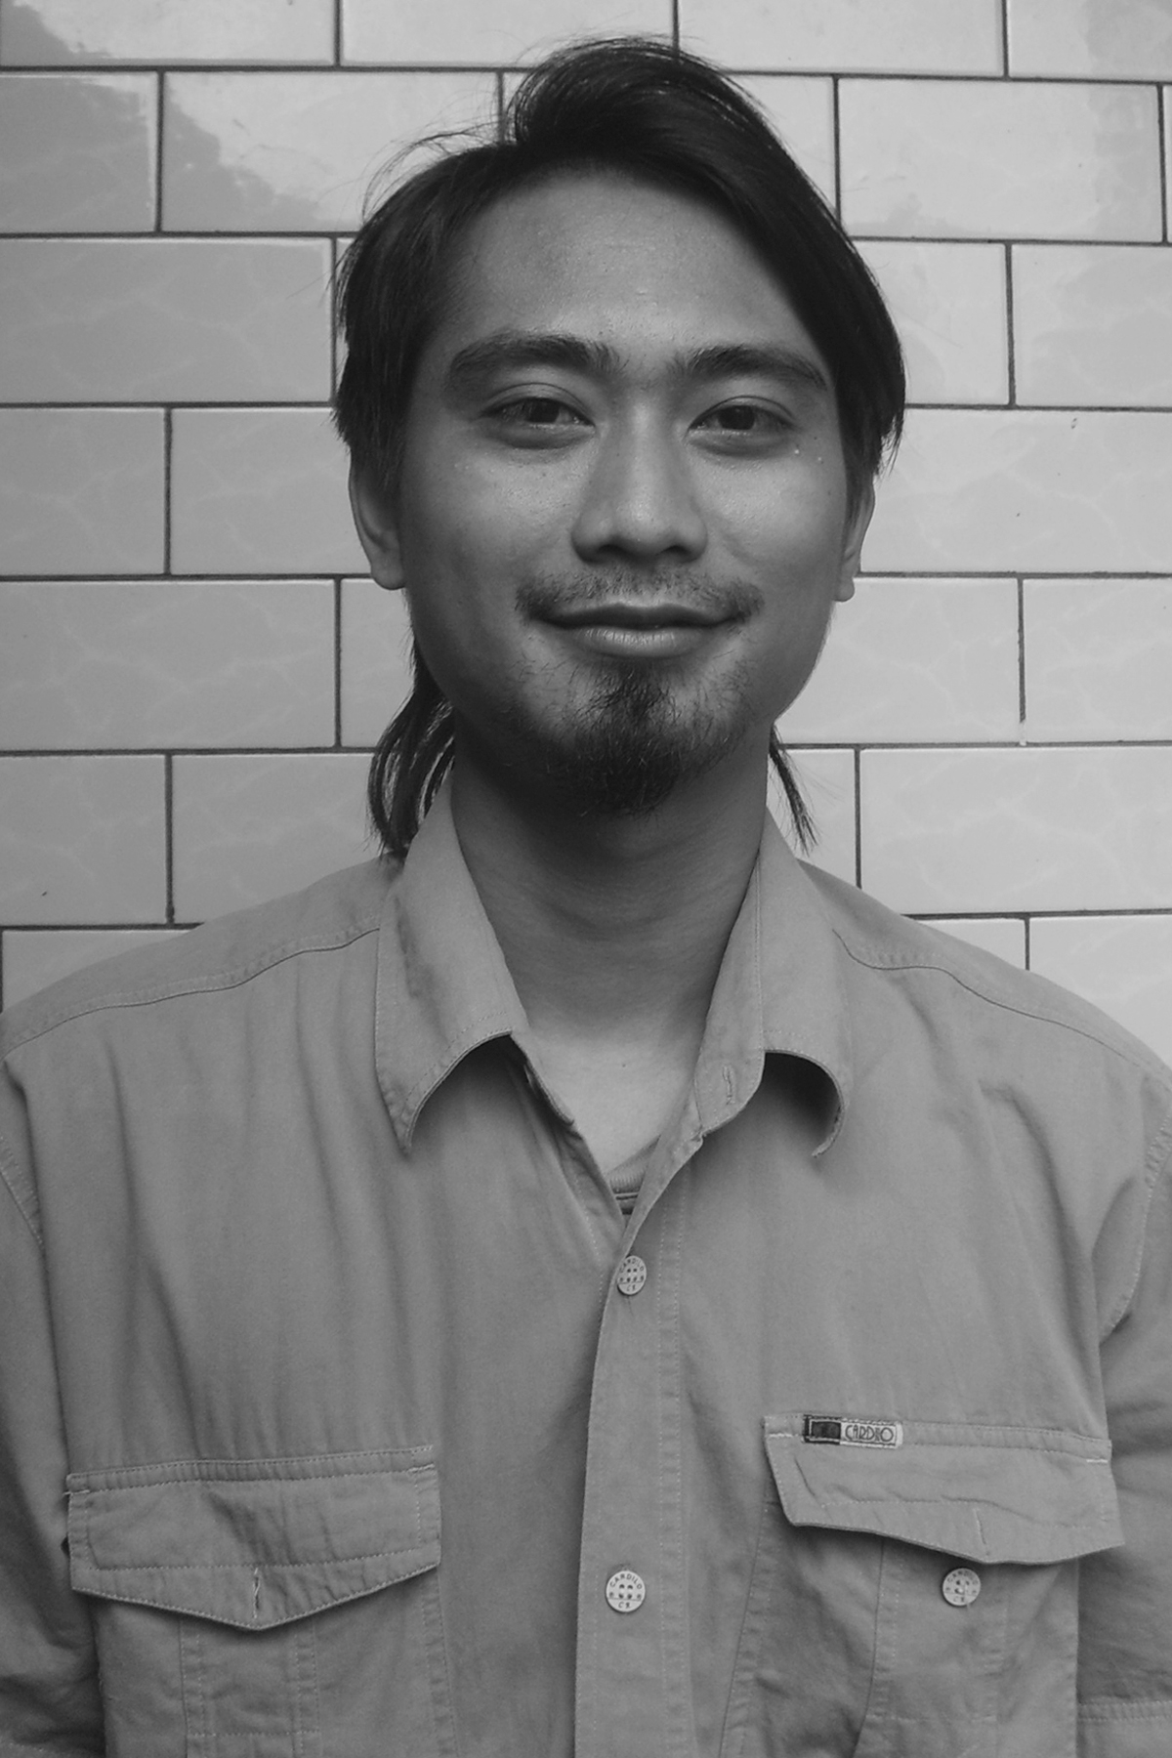

Curriculum Vitae

Personal Data
Name : Bahtiar Dwi Susanto
Nick Name : anto
Date of birth : 28.04.1979
Address : De Green Terraces B1 No.5-Kalisuren-Tajurhalang-Bogor-Indonesia
Email : bahtiardwisusanto@gmail.com
Website : www.bahtiardwisusanto.wordpress.com
Mobile No : +62- 8156 774 7798
Education : Bachelor Degree on Communication Dept. of Muhammadiyah Malang University
Selected experiences
Solo :
    - Melihat Bersama (Seeing Together) Exhibition (Indonesia-Malaysia Inisiation), Ken Arok Gallery – Malang and CCCL (Centre Cultural et de Cooperation Linguistique of France) Surabaya, Indonesia, 2009
    - Fragment Exhibition, House of Royal Bank of Scotland – Penang – Malaysia, 2010

Residency Program :
- Artist in Residence – Malihom Penang-Malaysia from January until June 2010
- Artist in Residence – Rimbun Dahan-Malaysia from November 15, 2007 until January 14, 2008
Symposium :
- Artist Presentation on ISEA2008 (International Symposium Electronic on Art) Singapore, 2008.
- Futuresonic group discussion, presentation project on artwork and theme concern, Singapore, 2008
Group :
- Tribute to Man Ray (INSOMNIUM), CCCL Surabaya, 2010
- Trienial Of The Extended Art Media, Serbia, 2010
- Ongoing Echos, Myanmar – Indonesia Art Exchange, Yangon - Myanmar, 2010
- Tribute to Man Ray Exhibition (Group of INSOMNIUM Indonesia), Mamipo Malang, Indonesia, 2009
- Festival Film International – Malaysia (Kuala Lumpur, Johor, Penang), 2008.
- Indonesian Dreams, Group of Photography Exhibition, Erasmus Huis, Jakarta, Indonesia, 2008
- “Kampoeng Project” as making basic of art building at village with visual shock therapy, an independent project, August 2006 until January 2007
- Fotogram Exhibition - Mess56 Yogyakarta Indonesia, 2005
- Tujuh Hari Plus a Group Photo Exhibition, Gelaran Budaya Yogyakarta, 2001

Activity :
- INSOMNIUM Malang, Indonesia, 2003 (until now)

Award :
- Artsnetworkasia (ANA), Travel Grant, 2007

