SONJA DIMITROVA

Hemus 61,vhA/app49/et10  Geo Milev,Sofia  1574  R.Bulgaria  Tel: ++359886252946  Tel: ++38977940 322  sonjadimitrova@gmail.com  DOB: 11 November 1979 | 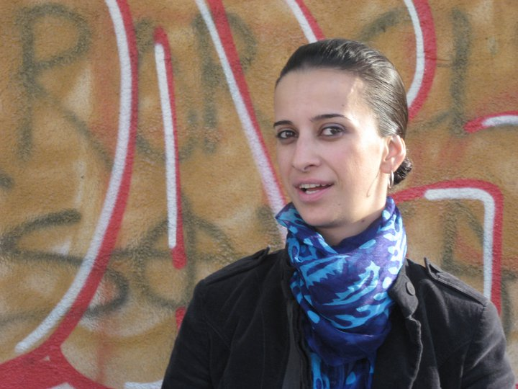

EMPLOYMENT HISTORY

ARTIST DECORATOR AT BESPOKE TEAM EOOD :  Sofia- painting decoration for private house  New York - silver plated panel 14m x 4m.  Tel Aviv - painting decoration for Mr. Avi Levi  Sofia - Hand painted wallpaper for private house  Izmir - painting decoration for Mr. Arkas Residence  Istanbul - painting decoration in Camondo residence  Istanbul – painting decoration in Hotel Crown Plaza Istanbul  Istanbul – decoration in Chiragan Palace – Kempinski Hotel | 2011  2010  2009  2009  2008  2007  2007  2006 – 2007
TAPESTRY WEAVER ,STUDIO ASSISTANT  West Dean Tapestry Studio  Working on a commission for Saïd Business School, Oxford University.  Responsibilities included making cartoon from John Hubbard original watercolour; dyeing yarn; warping up; sampling; weaving and finishing. | 2002 – 2006
VARIOUS TEXTILES COMMISSIONS, ASSISTING ANN CARRINGTON  Including work for Vivienne Westwood; Paul Smith and Elton John  MEMBER OF SOCIETY OF DESIGNERS & CRAFTSMEN, UK | 2004 – 2005

EDUCATION
INSTITUTE FOR DECORATIVE PAINTING  VAN DER KELEN-LOGELAIN  -GOLDEN MEDAL  BRUSSELS,BELGIUM  PROFESSIONAL DEVELOPMENT DIPLOMA,  TAPESTRY WEAVING  WEST DEAN COLLEGE, UK | 2011-2012  2002 – 2003
NATIONAL ACADEMY OF FINE ARTS  BA-TEXTILE  1ST HONOURS  SOFIA, R. BULGARIA | 1998 – 2002
EXHIBITION

2000 - The 2nd Textile Biennale, Shipka 6, Sofia, R. Bulgaria

2001 - The 3rd Textile Biennale, Shipka 6, Sofia, R. Bulgaria

2003 -“Just the tree of us”- Final Show, West Dean College,

2004 - “The 14th Annual Designers & Craftsmen Exhibition”,

The Mall Galleries, London

2008 - White Nights, Skopje, R. Macedonia

2010 - Museum of Contemporary Arts ,Skopje, Solo Exhibition

2010 - Macedonian Center for Culture, Sofia, Solo Exhibition

2010 - San Francesco, Treviso, Italy, Group Exhibition

2011 - Santo Stefano Belbo, Italy, Group Exhibition

AWARDS:

“The Valerie Power Memorial Prize”, for the most innovative
work-2003, West Dean College

