Trees: Mankind

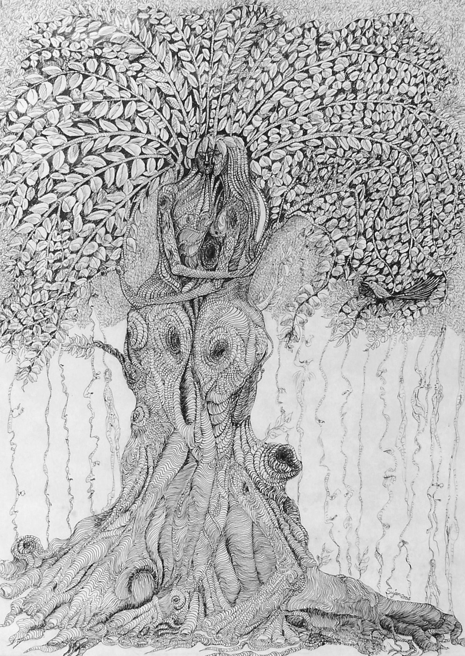

Artist Sujan Biswas has made the world of Nature the leitmotif of his art creations. In his works one can almost breathe the freshness of trees, their close relationship with the people who inhabit his canvas, not as individuals but as a part of the arboreal world around them. In fact, the trees in his works loose much of their individual identity and become embodied as the limbs and body parts of the human world. In consequence, the interdependence between man and nature is writ in explicit terms in all of Sujan Biswas’ works. Through the masterly strokes of his brush, the fine lines of pen and ink details and a colour palette that weaves meaning through various tints and shades, this skilful artist has driven home the urgent message that the wanton destruction of trees and their lack of upkeep is the way to environmental degradation, and the celebration of creativity can be verbalized through such poignant messages on canvas.

This succinct bonding between man and trees has found voice in the art works through a unique methodology of transformation. Biswas seems to start out with making a tree on the canvas but somewhere down the line, the creative palette manifests itself into a human form with the body part construed from a mature tree, and the energy of growth and rootedness nurturing its lifeline, while the sinuous twists of branches and leafiness, are the post scripts reminding one of the subtle connectivity that weaves together the man-nature relationship. Works like ‘Transformation’ are evidences of this thought process.

Not all his inspirations are rooted ideas for in works such as ‘Flying Tree’, the composition exudes freedom arising from within the artist. The floating tree forms are a manifestation of a journey towards a global outlook, taking the message of amalgamation between the end points of tree and man to a heightened level of sensitivity. In an intricate play of sinuous lines on a wash of blues and greys, the twisting of sinew and bark depicts the message of concern, dedication and hope, that are but staging posts in man’s quest to save the environment. The fine lines outlining detached tree forms and blurred bird forms create an aura of mysticism, for surely nature is not all a story of concern for its safety; it is also the magical liberty of the artist to evoke images from memory and distant dreams that lie dormant in the sub-conscious.

At other times, Biswas resorts to myths and legends to express his environmental vision. The wavy pen strokes conjure visages of mythical goddesses such as Saraswati and Durga and the demon Mahisasura is a distinct form, with the trio expressing the energy that exudes when the struggle comes to a victorious ending. Using the visual appeal of mythology again, and within the tree formation, he enriches the work with emotive effects.

At times, Sujan Biswas veers away from canvas and sketchbook and works on gnarled roots, storm-damaged tree trunks, or weather beaten branches, smoothening their raw edges to express the nuances of human emotions, the welcoming arms of Mother nature or just the joy of creativity, style and the wonders of ingenuity.

Since the early beginnings when a tree was nothing more than a physical form for him, today, Sujan Biswas, holding his … solo exhibition, has widened his art concerns, embracing social imperatives, universal messages and personal revelations about Man and his links with nature’s most representative form, the Tree.

