Sandra D’Angelo 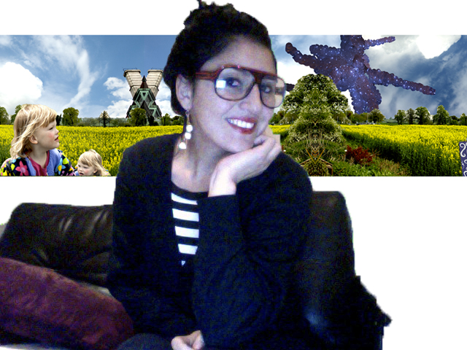

Lives and works in London (Shoreditch).

Contacts: maria_alessandra.d’angelo@kcl.ac.uk
www.celesteprize.com/sandradangelo
www.vzgallery.com/photography/SANDRA_D_ANGELO

2015
Ph.D King’s College, London

2013
M.Phill Researcher King’s College, London

2004 – 2006
MA in Fine Art, (Distinction) Accademia di Belle Arti di Brera, Milan

1999 - 2003
BA in Fine Art (Hons), (First Class) Accademia di Belle Arti di Brera, Milan

-------------------------------------------------------------------------------------------------------------------------------------------

BIOGRAPHY & ARTIST STATEMENT

Academic researcher, visual artist and electronic music producer.

In her portraits Sandra D’Angelo reflects a topic that is the main theme of her academic research. Musicology and anthropology are related to her work since 2007 when she started reworking and theorising a cultural phenomenon recently originated in the slums of Rio de Janeiro: a cultural movement named Baile Funk.

As a visual artist and researcher D’Angelo combines in her portraits a scientific and objective anthropological analysis to an emotional and subjective artistic vision, a mix between an epic journey through monumental and mystical little humans and a sociological cultural investigation.

Sandra is the first University researcher to propose Baile Funk as an academic topic as well as an artistic subject.

Each penetrating portrait, digitally altered Ilfochrome prints and Baile funk music installations offer us fragments of stories that we, the viewers, are left to complete through a intimate interpretation.
Subjects are caught in the moment of their introspective emotion; out of context, they are re-contextualised through an outlet of surreal evocative scenarios.
D’Angelo poses her models in her studio most often against a bare wall and then digitally adds the backgrounds, borrowed from photographs she has taken on her travels in Brazil and UK. She also takes a series of detailed shots of leaves, flowers, plants and insects. After collecting hundreds of images, she carefully selects those images that can best achieve the required effect.

The surfaces of these photos have a lustrous, pearlescent sheen that evokes the same magic Old Masters knew how to produce with their long-lost alchemy of finishes and glazes.

In the series Pandora’s Box, children are all Brazilian and mainly coming from underprivileged areas in Brazil where Baile funk represents the main music. In their artificial paradises they look like dolls, a bit like little fashion models and, become, in D’Angelo portrait’s, fantasy creatures and mystical subject types.

Sunny skies, sophisticated surreal atmospheres and electronic percussive elements mixed with D’Angelo music productions, work as a gratifying and consolatory background of the flaunted brutality of the world. The magnifying glass, sometimes deforming more than ever, is buying up the essence of things, characters, gestures and idiosyncrasies, collective and degenerative diseases.

The sedimentation of the strata of personal experiences leads D’Angelo to seek a vehicle to explore the unforgettable experience of the self; thus what unites all the works of D’Angelo, although stylistically, is the analysis of the complex nature of Human beings.

In each series of D’Angelo’s electronic images and music, sometimes the visual impact eclipses the satirical message. Seductive images are organized structures which magnify and mock a new and clear aesthetic notion, where human beings lose their identity and become surreal myths inserted in frameworks inspired from natural landscapes urban contests always full of an ethereal sense of beauty.

Sandra has taken the digital manipulation of photographs to a new level.
Her colorful images are synthetized from a myriad of elements, manipulating their fragments and traces rather like an artist uses paint. Trained at the Brera University of Fine Art in Italy, she creates, with digital software, complex images, sometimes spending months working on the synthesis of a particular photo-derived scenario. Beginning her career in music, Sandra entered the world of art photography after her BA in Fine Arts. Initially working in black and white portraits she quickly graduated to color photography and soon the enhanced opportunities offered by digital manipulation presented her with a whole new palette of possibilities.

In her artworks, Sandra, approaches different topics such as an understanding of ancestral fears in Robotic Paleolithic; freedom, justice and aspirations in Metaphorical Freedom, eccentricity, talent and preconceptions in Petruska and London Lovers.

In 2013, Sandra D'Angelo will also play the role of Deputy Mayor for International Relations for Athensart international Art Festival organized by the Brazilian government in Rio de Janeiro in 2013.

MUSIC

Sandra also works for the international pop music industry and major music labels such as Emi/ Virgin;

Her name has appeared internationally in the worlds of singing, songwriting and Tv and Radio commercials, although she is equally singing for quality independent labels like Schema Records and Irma Records. In 2008 she beat off hundreds of contestants to be selected for the “Edison Change The Music” competition with her Baile Funk track “Eco Killers” where they appreciated her fresh musical approach which is further highlighted by the fact she was the first singer to perform a brand new genre of music coming from Rio de Janeiro’s favelas (slums) named Baile Funk never heard before in Italy: her performances were on important italian music televisions such as “MTV” and “All Music”.

Her brand new project is a mix of dancehall, miami bass, electro, samba, jungle and world music that has made an immediate impact with Brazilian djs and producers from New York to Rio De Janeiro and London, where she usually performs. She is presently collaborating with some of the biggest names in the vibrant world of baile funk including New York based Xao Productions, Edu K (Man Recordings) in Europe and DJ Amazing Clay from the home of baile funk, Rio De Janeiro. Ever versatile Sandra has also recorded with world famous fidget house artists Defunct from the USA and recorded with the great UK label, Dangerbox Recordings notching up several top 100 chart hits on the worlds biggest download sites – Beatport, DJDownload and Trackitdown, to name just a few.
Sandra has exhibited and performed her artworks and music in New York, London, Milan, Athens, Rio de Janeiro, Sao Paolo, Paris.

art ExhibitioNS (SOLO AND GROUP)

2013 Brazil ART FESTIVAL, UBA, MINAS GERAIS
2012 UK VZ Gallery, Shoreditch, London (Solo)
2011 BRAZIL galeria martha carvalho, ipanema, rio de janeiro.
2010 brazil MAAP/Museo Aracatubense da arte, SAO PAULO (SOLO)
2010 greece GAZI, TEchnopolis, Athens.
2009 uk BIrKbeck university, london.
2003 Germany Staatliche AKADEMIE DEr BildendeN Kunste, Dresden.
2002 italy Palazzo della permanente, SAlon 1, Milan.

RESEARCH
2010 CATALOGUE PUBBLICATION “ATHENS INTERNATIONAL ART 2010”
2010, DOCTORATE RESEARCH TOPIC : VISUAL ART AND MUSIC EXPRESSIONS FROM FAVELAS OF RIO DE JANEIRO.
2006, RESEARCH “COLORIS ET MUSICA” HOW TO ANALYSE THE SENSATION GIVEN BY SOUND AND COMMUNICATED INTO COLOUR.
2003, RESEARCH “CONTEMPORARY ARTS AND COMPUTER MUSIC: ANALYSIS OF THE NEW FORMS OF INTERACTION AMONG VIDEOART, PHOTOGRAPHY, AUDIOVISUAL INSTALLATIONS AND MUSIC WITH USE OF ELECTRONIC AIDS”.
GRANTS AND AWARDS

2008, MUSIC AWARD ORGANIZED BY ”EDISON CHANGE THE MUSIC” ITALY
2008, MUSIC AWARD ORGANIZED BY RAI TV, ITALY
2007 ALBUM OF MAFY EMI/VIRGING AND WALT DISNEY ITALY
2002 BURSARY, ERASMUS PROGRAMME, STAATLICHE HOCHSCHULE FUER BILDENDE KUENSTE-STAEDELSCHULE DRESDEN, GERMANY
2001, CARLA ACCARDI WORKSHOP, MILAN, ITALY
1999 FIRST PRIZE PAINTING AND DRAWING CONTEST “MONTALBO” ITALY
1998 - 2003, BRERA BURSARY AWARD, ACADEMIA DI BELLE ARTI DI BRERA, MILAN, ITALY

a selection of interview and performances
2010 november, radio cultura san paolo, SAo PAULO BRAZIL (Radio interview)
2010 november, newspaper “Folha da regiao” Sao Paulo BRAZIL (Newspaper article)
2010/10th/october, newspaper “Folha da regiao”, BRAZIL (Newspaper article)
2010 september, Radio OnRCS Milano interview, ITALY(Radio interview)
2010 MAY, Radio cultura san paolo, Brazil (Radio interview)
2008, MTV Music performance Sandra d’angelo DIRTY CANDY, italy (TV interview )
2008, ALL MUSIC TV Music Performance Sandra d’angelo DIRTY CANDY, italy (TV interview )
2001, Newspaper “Corriere della sera” reportage for the Salon 1 Palazzo della permanente, Italy (Newspaper article)

