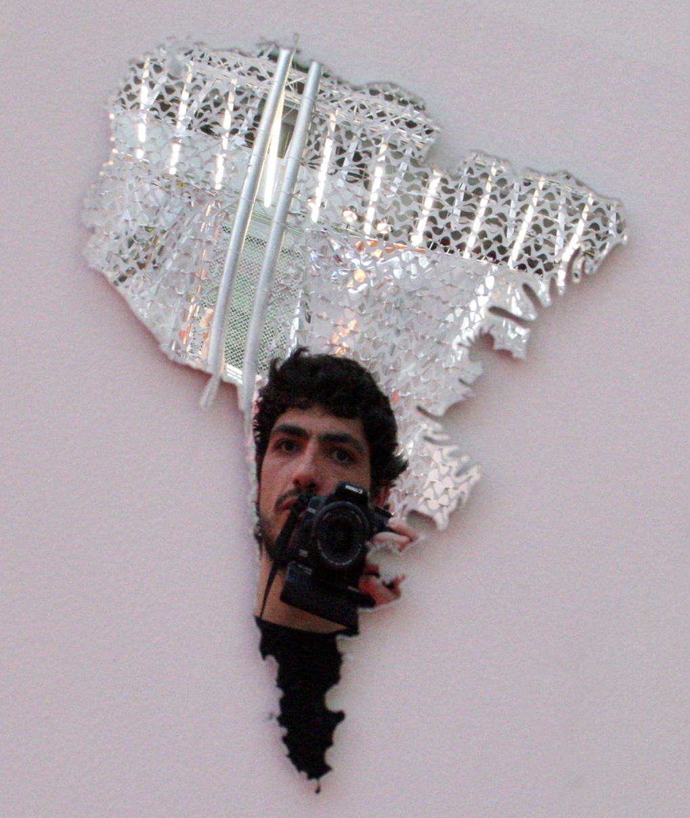
GIANCARLO PAZZANESE

Curriculum Vitae

CONTENTS:

- General Information
- Abstract of Curatorial projects
- Grants & funds
- Residence programs
- Selected exhibitions
- Short biography

1. General Information ....................................................................................................................

Name: Giancarlo Pazzanese Mardones
Date of birth: 17.08.1976
Nationality: Italian

Telephone NL : +00 31 (0)6 489 77 460
E-mail: gpazzanese@gmail.com
Postal address: Postbus 17362. 1001 JJ Amsterdam, The Netherlands

College Studies:

1999 Diploma in Multimedia Communication
Universidad del Pacífico. Chile

1994-1998 Bachelor in Arts
Universidad Católica de Chile

Languages: Fluent in Spanish, English & Italian
Basic Dutch

2. Abstract of curatorial projects 2009

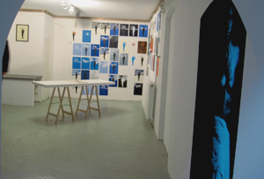
2009. Not Another Girl Show
Eye Witness Project Space. Amsterdam, The Netherlands
Exhibition with works by Tia Renee Ryan (US) and Mate Zabala (CL)

Description: Bi personal exhibition with site specific works reflecting on issues of identity construction and migration. Video installations and prints that reflect on art production and gender exhibitions.
Role: Curatorial concept, planning, production and internal/external communications.

……...........................…...........................…...........................…...........................…..............................
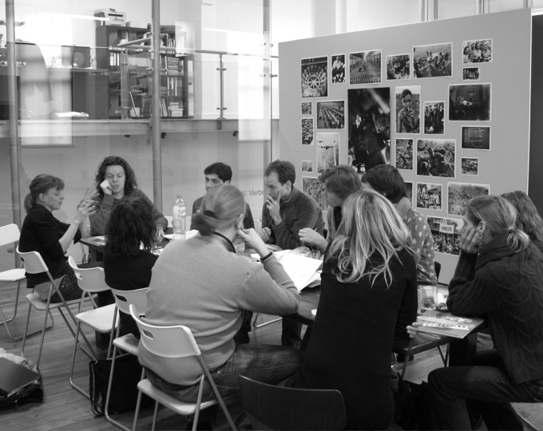
2009. Stop Making Sense. Het Proces
Eye Witness Project Space. Amsterdam, The Netherlands

Description: 4 month curatorial training program organized by Kunstenaars en Co and Van Gogh Museum. End show consisting of a 3 day art program with video, installations, performances and a lecture.
Role: Program production and internal/external communications, website design.

……...........................…...........................…...........................…...........................…..............................

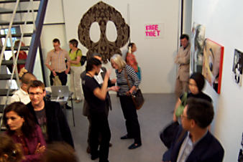
2008. Liste 2008
International Art Fair. Basel, Switzerland

Description: Participation in Liste 2008 as only art organization from South America. Collaboration with Traschi Gallery from Chile and Pro Chile office of cultural promotion from the Ministry of Foreign Affairs.
Role: Stand production, communications, fund raising, sales & customs management.

……...........................…...........................…...........................…...........................…..............................
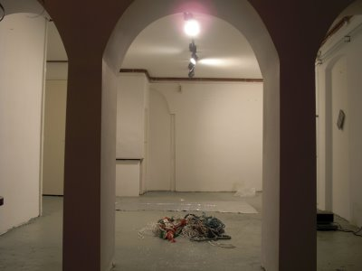
2008. Untitled
Eye Witness Project Space. Amsterdam, The Netherlands
Exhibition with works by Luis Guerra (CL) and Paula Cobo (CL)

Description: Bi personal exhibition with site specific works reflecting on issues of econimic crisis, social revolts and migration. Video production and object installations.
Role: Curatorial concept, planning, production and internal/external communications.

…...........................…...........................…...........................…...........................…..............................
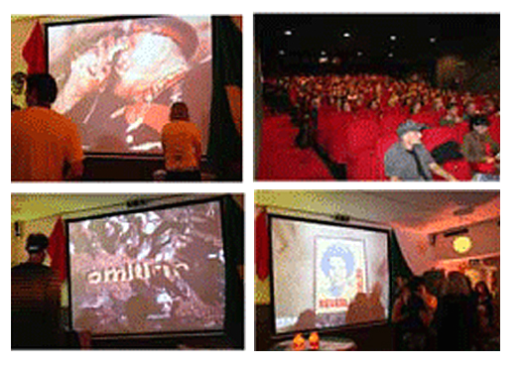
2007. Politically Correct
Latin American Film Festival (LAFF). Utrecht, The Netherlands

Description: 30 min. video program showing a panorama of digital and political works from young artists active after 20 years of the military dictatorship in Chile.
Role: Curatorial concept, video selection, program production and internal/external communications.

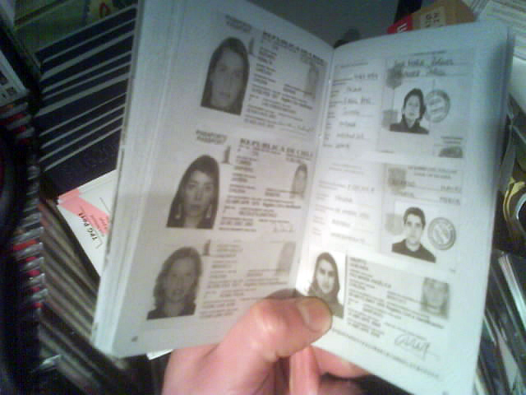
2006. Eye Witness Editions: Passport Nr. 001

Description: Artist book designed in the form of a passport, it’s objective was to contain the various actions and interventions, small and large, intimate and public from a 3 month residence program. Publication containing texts, images and material from city interventions, meetings and exhibitions. Role: Editorial concept, text coordination, print production & distribution.

…...........................…...........................…...........................…...........................…..............................

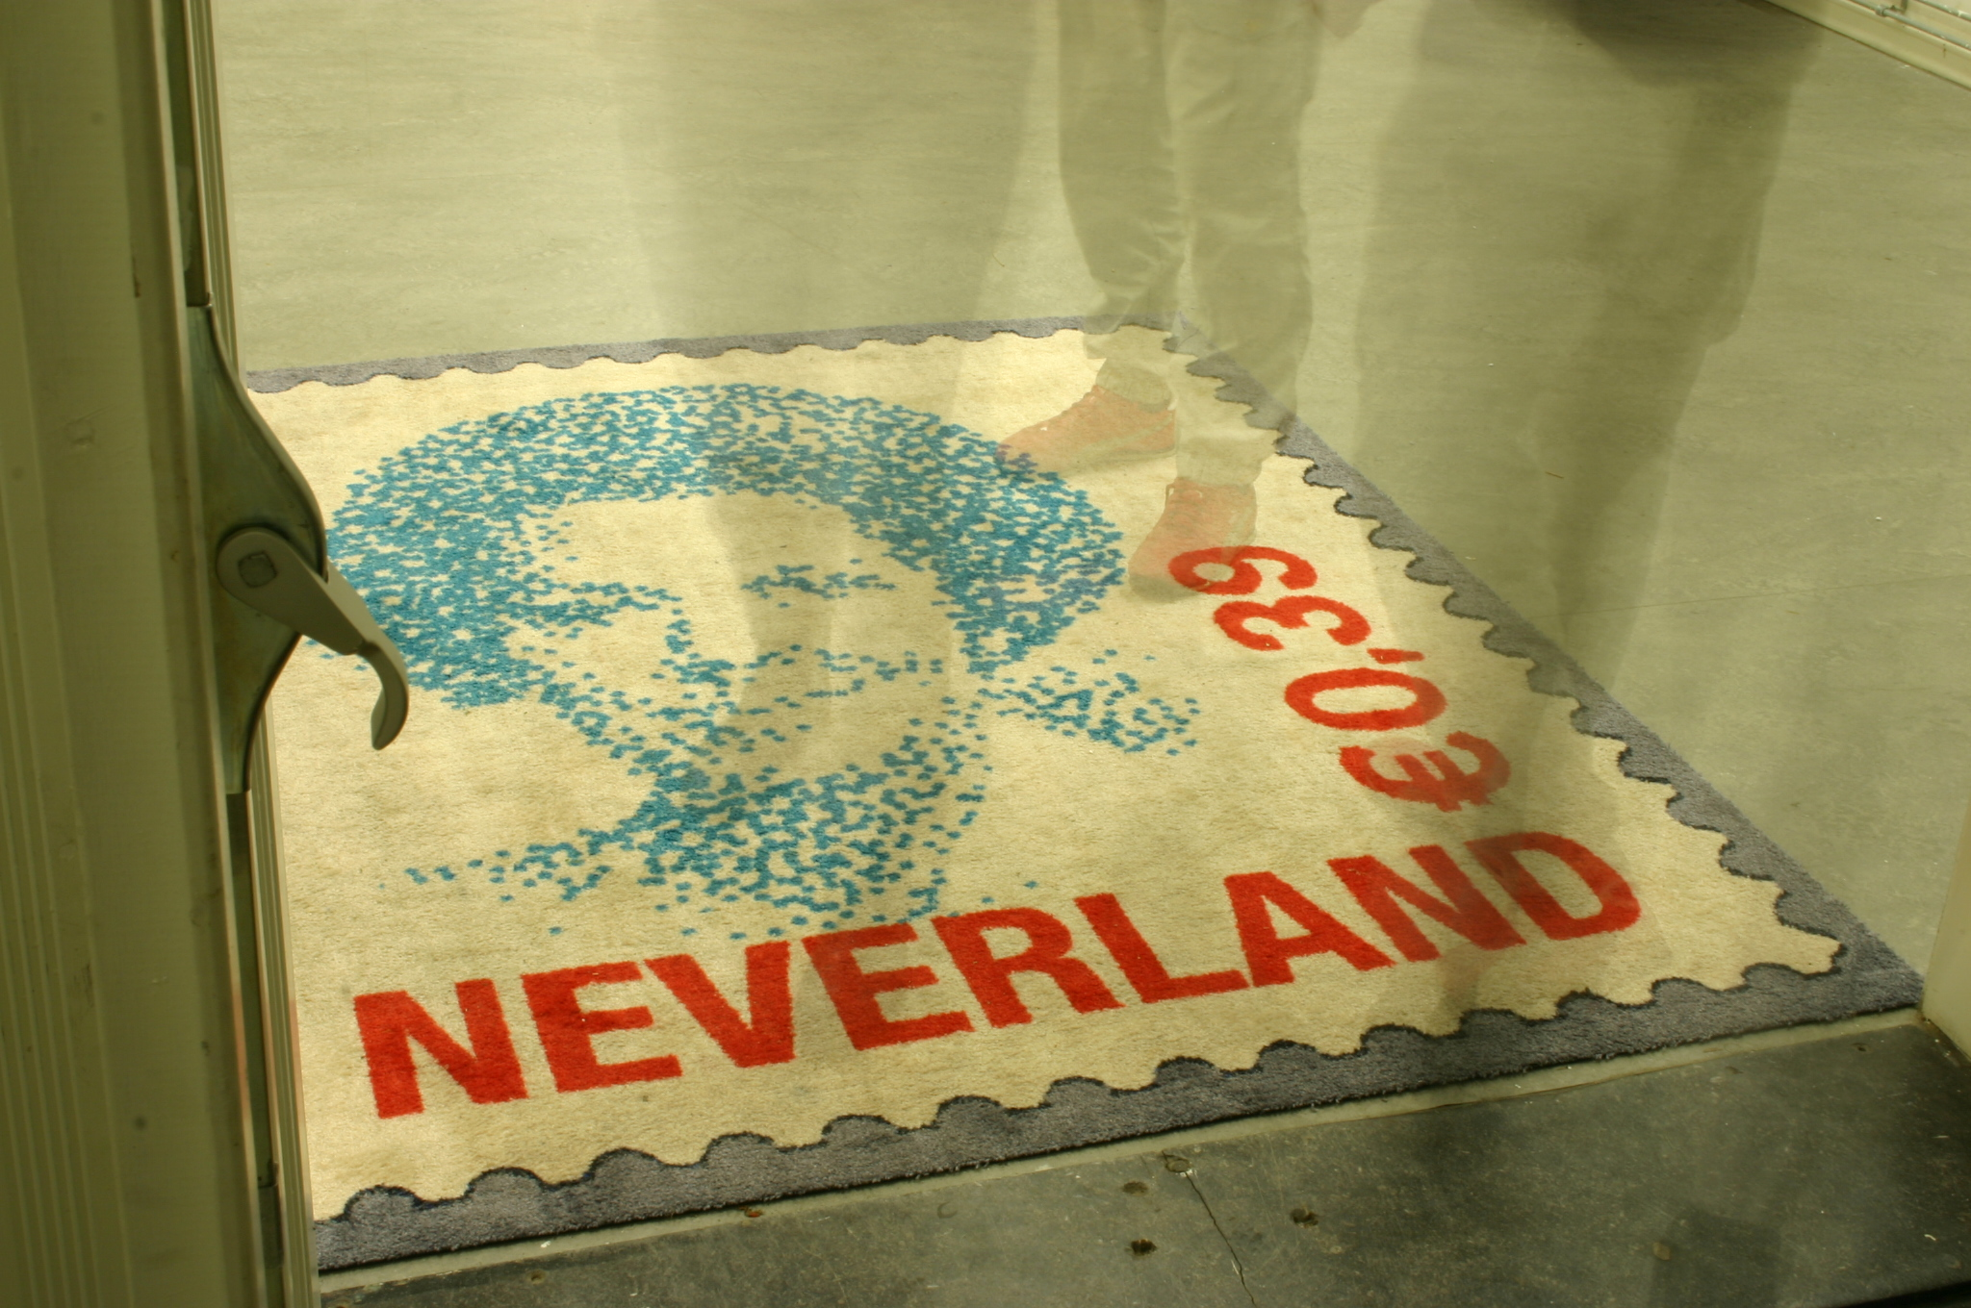
2005: Pirate Art: “Truly, truly false!
Het Wilde Weten Foundation. Rotterdam, The Netherlands

Description: Group Exhibition on contemporary Chilean art. Reflections on cultural heritage, national identity and integration problems. Selection of 'translocal' Chilean artists around the subject of the pirate copy in relation to contemporary art markets and migration from South America to developed countries.
Role: Curatorial concept, all round production, fund raising, documentation
And internal/external communications

…...........................…...........................…...........................…...........................…..............................

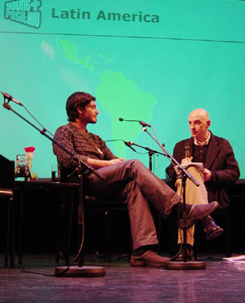
2002: HIV Informal Report: Chile
Royal Tropical Institute. Amsterdam, The Netherlands

Description: Film about life with HIV in Chile. Focused on independent awareness initiatives and the depiction of a double standard society, social stigma and religious dogma. The starting point was: How can art help in such negative conditions?
Non-narrative mini-dv documentary of 30 min. presented on the World’s AIDS Day 2002, commissioned by the RTI Amsterdam.
Role: Video concept, direction, production, postproduction and public presentation.

…...........................…...........................…...........................…...........................…..............................

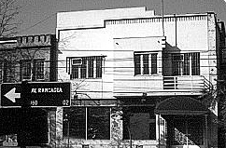
1999: CASASUCIA

Description: Group exhibition that set a new trend in the Chilean art scene of the late 90’s. This artist’s initiative appropriated a small family business model by renting a broke boutique to install a temporary art production machine. Reflections on sexual identity, reproduction, dysfunctional families and brotherhood.
Role: Curatorial concept, general production, and artist coordination.

3. Grants & funds............................................................................................................................

2008 Pro Chile
2008 DIRAC Polinesia
2006 DIRAC – Home away from home, Ministry of Foreign Affairs, Chile
2001 FONDART, National Funds for the Arts, Chile
2001 KENT Explora digital print contest, Chile

4. Residence programs....................................................................................................................

2008 Galeria Traschi, Santiago. Chile
2007 CAUCUS. Becoming Dutch Programme. Van Abbe Museum. Eindhoven, The Netherlands
2005 Het Wilde Weten, Rotterdam. The Netherlands

5. Selected Projects & Exhibitions ................................................................................................

2009
-Not Old Enough. Radar Gallery. Amsterdam, The Netherlands
-mAssage. Galerie Caesar & Coba. Hamburg, Germany
-Politische Fiktionen. European Media Art Festival. Osnabrück, Germany
Recent Art from Chile. Accademia di Brera. Milan. Italy
-Stop Making Sense. Het Process. Eye Witness Studio. Amsterdam, The Netherlands

2008
-No Label. Dutch esign Center. Utrecht. The Netherlands
-Archivo Sur. Futura Center for Contemporary Art. Prague, Czech Republic
-Guangzhou Triennial. Guangdong Museum of Art. The Tea Pavilion. Guangzhou, China
-Felicidad. Polinesia Gallery. Sao Paulo, Brazil
-We believe in Art. Traschi Gallery. Santiago Chile

2007
-The Political Landscape, Kunsthalle Berlin-Lichtenberg, Germany
-Sewn, China-Chile. Segment Space. Beijing, China
-Wrong Time, Wrong Place, TENT Rotterdam Center for the Arts. The Netherlands

2006
-Home away from Home. Embassy of Chile in Washington DC.
-Streaming Video Festival, Den Haag
-Rotativo, H10 Gallery, Valparaiso Santiago

2005
-Sex Symbol, CBK Center, Rotterdam
-Videocracia, Berlin. Germany
-Chile –Suecia. Stockholm, Sweden

2004
-Italia-Chile. Artisti in Confronto Latinoamerican - Italian Cultural Institute. IILA, Rome. Italy

2003
-Latinoamericaoff, Galleria Aleph, Rome. Italy
-Toy paintings, Virgilio, Sao Paulo. Brazil

6.Biography...........................................................................................................................

Giancarlo Pazzanese is a first generation born son from an Italian immigrant who came from Napoli to Santiago de Chile in the late 50’s. GP was a foreign exchange student in Iowa, USA when he was 15 years old. During 1994 – 1998 he studied in the Arts School of the Catholic University in Santiago, Chile. Since then he is active both as visual artist and art producer.

He worked 2 years for the FAO-UN headquarters in Santiago until the end of 2002. During this time he organized exhibition projects and produced video and installation pieces that were stored in a digital web-archive called “18cm” (www.18cm.nl).

In late 2002 he relocates to Amsterdam. From there, he starts to implement an artist organization called Eye Witness (www.testigoocular.org) whose first project was the creation of an artist in residence project that took place during June and September 2005 in the city of Rotterdam. Together with this residence experience he organized a group show on Chilean art called Pirate Art: Truly, Truly False! that was exhibited in September 2005 in the artists space Het Wilde Weten and later part of these works were exhibited in at TENT Center for the Arts in Rotterdam. After that, he settles back in Amsterdam where he lives and works as visual artist and independent curator since February 2006.

Since then Giancarlo is actively working as visual artist and freelance curator and is in constant collaboration with the Chilean Embassy in The Hague and other institutions such as the Ministry of Foreign Affairs from Chile and the curators program Het Proces from Kunstenaars & Co in The Netherlands. He also works as consultant for communication agencies in the development of social marketing campaigns related to culture, health and migration.

