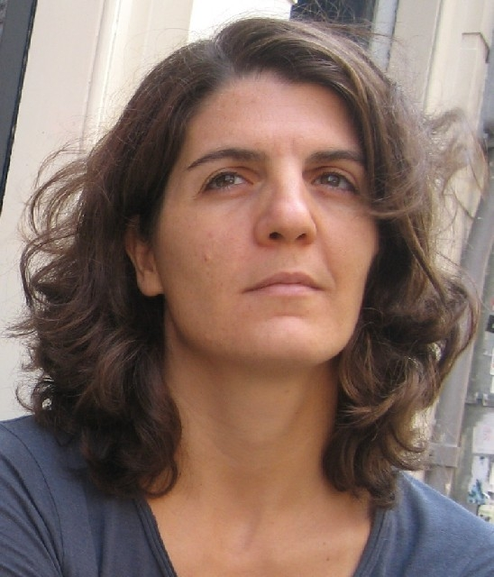
PLACE & DATE OF BIRTH Kozani - Greece in 13/3/1975

ART EDUCATION
1993 Stained Glass courses in Thessaloniki - Greece
1998 Puppets making by pappies masse in Athens - Greece
2005 - now Printmaking Workshop, "Hellios" Center, Thessaloniki, Greece

GROUP EXHIBITION
1999 D.E.P.K.A. (Cultural Centre of the Community of Serres) - Women's creation, Serres – Greece.
1999 With the group "Fourfouri" representing the D.E.P.K.A. at the Educational EXPO in Thessaloniki.
2005 1st International Arad Biennale of Contemporary Art, Romania.
2005 3a BIENAL INTERNACIONAL DE GRAVURA - DOURO 2005, Portugal.
2006 Bella Arte Lamia '06 Modern Art Concept - Lamia, Greece.
2006 Printmaking Center "Hellios", Thessaloniki, Greece.
2006 International Exhibition of Digital Arts, M.I.A.D. VENADO TUERTO, Argentina.
2006 "Het licht op Saskia", World Art Delft , Delft, Holland.
2006 4th International Biennial of Miniature Art - Czestochowa, Poland.
10/2006 Art Space "VLASSIS ART.COM", "Dialogues" with the group "Connecting - Art" - Thessaloniki, Greece.
12/2006 Art Space "VLASSIS ART.COM", with Printmaking Center "Hellios", Thessaloniki, Greece.
12/2006 8th International Book Art Festival, at the Book Art Museum in Lodz, Poland.
1/2007 Art space center "Aris Garoufalidis", with the group "Connecting - Art", Ptolemaida, Greece.
2/2007 "Cultural Events in the Old City of Xanthi", with the group "Connecting - Art", Xanthi, Greece.
2/2007 "International Mother Language Day", Nepal Art Council Gallery, Babar Mahal, Kathmandu, Nepal.
3/2007 "WAD Aqua", World Art Delft, Delft, Holland.
5/2007 “International Museum Day”, Archeological Museum of Aianis, Kozani, Greece.
5/2007 Printmaking Center "Hellios", Thessaloniki, Greece.
6/2007 LESSEDRA World Art Print, Bulgaria (catalogue).
6/2007 “A day with Picasso”, Buriganga Arts, Dhaka, Bangladesh.
9/2007 “Art Exhibition of 7 Countries” National Art Gallery of the Bangladesh Shilpakala Academy, Bangladesh.
10/2007 "Borstbeelden", World Art Delft, Delft, Holland.
10/2007 Book art, NATIONAL PRINT MUSEUM, Dublin, Ireland.
11/2007 “Public art space I”, street art at the old city of Thessaloniki, Greece.
11/2007 Bella Arte Lamia '07 Modern Art Concept - Lamia, Greece
11/2007 1st International Mail Art – The Philosophy Day, Vlassis Art.Com, Thessaloniki, Greece.
12/2007 “Merry Christmas”, Cultural Center of Spain, Tegucigalpa, Honduras.
2/2008 "International Mother Language Day", Asiatic Society of Bangladesh, Dhaka, Bangladesh
3/2008 Naestved International Mini Print Exhibition, Naestved, Denmark
4/2008 International Identification Document Exhibition, The Museum of Arts & Crafts-Itami, Hyogo, Japan
5/2008 6th International Miniart Exchange, Galeria Xico Stockinger de Casa de Cultura Mario Quintana, Porto Alegre, RS, Brazil
5/2008 Printmaking Center "Hellios", Thessaloniki, Greece
7/2008 “Evento International Digital Art The WAVE 2008”, Genoa, Italy
7/2008 8th International Miniart Exchange Amazon, Centro de Artes da Universidade Federal do Amazonas, Manaus, Brazil
10-13/7/2008 Photography Center of Thessaloniki, “Taste 4 Arts”, at Earth Festival, Vlasti, Kozani, Greece
8/2008 10Th International Symposium of Contemporary Art D. Fleiss & East West artists, Carei 2008, Romania
8/2008 5th International Biennial of Miniature Art - Czestochowa, Poland.
8/2008 International Identification Document Exhibition, Zaim, Yokohama, Japan
8/2008 Land art “Moved Wind” Korbach, Bad Arolsen wind park, Germany.
10/2008 Galeria Lepoldo Carpinteyro de Relaciones Culturales, “Grabados por la Paz 2008 - 1st International Prints for peace Mexico”, Monterrey, Mexico.
29/10-20/11/2008 1er Festival Internacional de Pintura CIUDAD DE LABOYOS 2008, GALERIA DE ARTE LA TERRAZA, Pitalito - Huila - Colombia
11/2008 Art Gallery of Antalya Museum in Turkey, Mediterranean Artists Group and its 1st Exhibition “TRAVELERS OF COLOR”
11-12/2008 International Identification Document Exhibition, 2B Galéria, Budapest, Hungary
1/2009 International Identification Document Exhibition, Galerie Kurt im Hirsch, Berlin, Germany
1/2009 “Dos oceanos un mar”, Centro de las Artes, San Luis Potosi, Mexico
2/2009 International Identification Document Exhibition, GALÉRIA Z - Bratislava, Slovakia
2/2009 “Dos oceanos un mar”, Fac. de Arquitectura de Universidad Nacional Autonoma de Mexico, Mexico.
2/2009 “International art exhibition Dali & Others”, BILIA Auditorium, Dhaka, Bangladesh.
3-4/2009 10th International Miniart Exchange, Universidad Autonoma de Nuevo Leon, Fac. de Arquitectura, Atraves de su Unidad Caltural, Barrio Antiguo, Monterrey, México.
3-4/2009 GRABADOS, 1st International Printmaking Collective 2009, Fac. de Arquitectura, Atraves de su Unidad Caltural, Barrio Antiguo, Monterrey, México.
4-5/2009 International Identification Document Exhibition, Galería Ajolote Arte Contemporáneo, Guadalajara, Mexico
6/2009 “The Other Half”, TETTIX ART GALLERY and VLASSIS ART.COM, Thessaloniki, Greece
9/2009 “4DELFT”, WAD, Delft, Holland
11/2009 “The Other Half”, Folk Art Museum of Xanthi, Greece
12/2009 “Cheap Photo”, TETTIX Gallery, Thessaloniki, Greece
12/2009 “Zone Zero – Gallikos River”, Municipality Exhibition Space, Kilkis, Greece
2/2010 Miniature Art Exhibition, VLASSIS ART.COM, Thessaloniki, Greece
3/2010 “Art Ways”, Piraeus Bank Convention Center, Thessaloniki, Greece
3/2010 Miniature Art Exhibition, Technohoros Gallery, Ioannina, Greece
6/2010 12th International Miniart Exchange, “Miniature Faces”, Art Gallery Dante Sfoggia, Brazilian-American Cultural institute, Porto Alegre, Brazil.
9/2010 “Friendship through art can change the world”, organized by the Center of art 4 seasonsTechnopolis, Gazi, Athens
10/2010 “Nostospassword” Art Banquet”,Fransız Sokağı Culture Center, Fransiz Sokagi girisi No:12/3, Istanbul, Turkey

INDIVIDUAL EXHIBITION
1995 Gallery "Pelasis", Serres - Greece
2006 Kafodeio "Orfeas", Lamia, Greece
6/10 – 7/10 Installation with prints “Cheerios” series, Grafisch Atelier Den Bosch Willem II Fabriek, Hertogenbosch, Holland

SYMPOSIUM
8/2006 Participation to the symposioum “Water", World Art Delft , Delft, Holland
- Outside installation "Water-tree"
- Video installation "Never Swim Alone"
8/2007 Participation to the symposium “Borstbeelden", World Art Delft, Delft, Holland
- Indoor installation “Going Forward”
8/2008 Participation to the symposium “Recycle Art", World Art Delft, Delft, Holland
- Installation “Tea Bag Diary”
5/2009 Participation to the symposium “Zone Zero – Gallikos River”, ATERMON Athletic Center, Kilkis, Greece
- Photographs “Reflection”
8/2009 Participation to the symposium “Homage of Delft", World Art Delft, Delft, Holland
- Installation “Dream – in Delft without baggage’s”
2-9/5/2010 Participation to the symposium “Grammatica dela Fantasia”, Verbania, Italy
20-30/5/2010 Participation to the symposium working with Homeless, Lyon, France
OTHER ACTIVITIES
2009 Organizing the “1st international Environmental Art Symposium Zone Zero – Gallikos River”, ATERMON Athletic Center, Kilkis, Greece
2008 Organizing the “2nd International Mail Art – Elimination of Violence against Woman”, Library of Technological Education Institute, Serres, Greece.
2007 Organizing the “1st International Mail Art – The Philosophy Day”, at Art Space “VLASSIS ART.COM”, Thessaloniki, Greece.
(Founding Member of “TeeToTuM” art group)
1998 – 2000 Teaching puppets making and performing with the group "Fourfouri"
(founding member) based at the Cultural Centre of the Community of Serres.
1993 – 2000 Working as stained glass maker.
1993 - 1994 Teaching Stained Glass making (Tiffany Technique) at the city of Karditsa.
AWARDS
2007 Critic Award for experimental print-medium, Buriganga Arts & Crafts, for the International Mother Language Day Art Festival, Kahtmandu, Nepal
2008 3rd Award of “L’onda - Evento International Digital Art The WAVE 2008” for digital painting, Genova, Italy.
COLLECTION
Nepal Art Council, Kahtmandu, Nepal
Bella Arte Lamia, Greece
Aiani Archeological Museum, Greece
COMMUNICATION
www.go-teetotum.gr
gogo@go-teetotum.gr
http://go-teetotum.blogspot.com
http://go-zone-zero.blogspot.com
Phone: +306945465559

