CURRICULUM VITAE
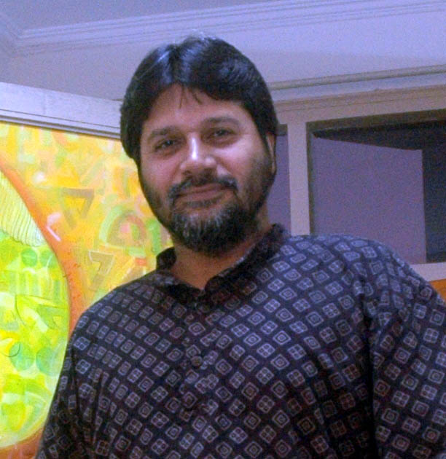
RESUME

MADAN LAL
Born in 1964 at Talwandi Bhai, Distt., Ferozpur (Punjab) India.

CORRESPONDENCE ADDRESS
Flat No 403, A.O.T Complex, Sector 48 - A, Chandigarh 160047
Phone No. [R] 0172- 2633581, 4620403 Mobile No. +91- 98149-04403
E- Mail: madan_artist@yahoo.com

SOLO EXHIBITION
2008 Exhibition of Painting Jahangir Art Gallery, Chandigarh
2007 Exhibition of Drawing & Paintings at Art Indus, New Delhi
2006 Exhibition of Painting at Art Folio, Chandigarh
2005 Exhibition of Paintings at Art Folio, Chandigarh
2005 Exhibition of Paintings at Triveni Kala Sangam, New Delhi
2004 Exhibition of Paintings at Lalit Kala Academy, New Delhi
2004 Exhibition of Paintings at Triveni Kala Sangam, New Delhi
2001 Exhibition of Drawings at Punjab Lalit Kala Academy, Chandigarh
1999 Exhibition of Paintings at Lalit Kala Academy, Rabindra Bhawan New Delhi
1998 Exhibition of Drawings & Paintings at Museum of Fine Arts, Punjab University, Chandigarh
1996 Exhibition of Paintings at Punjab Lalit Kala Academy, Chandigarh
1995 Exhibition of Drawings at Punjab Lalit Kala Academy, Chandigarh

GROUP EXHIBITIONS
2010 Exhibition of Untitled Paintings Punjab Lalit Kala, Chandigarh
2009 Exhibition of Painting Hega Park Stokholm, Sweden
2008 Exhibition of Painting Habitit Centre, New Delhi
2007 Exhibition of Paintings at Lalit Kala Academy, Rabindra Bhawan, New Delhi
2007 Exhibition by Nvya Art gallery, New Delhi
2006 Exhibition of Paintings by Art Indus at Habitat Center New Delhi
2006 Exhibition by Indian Art form at Habitat Center, New Delhi
2005 Polka Vision by Polka Art Gallery, New Delhi
2005 Harmony show Mumbai
2000 Exhibition of Paintings at Nehru Center, Worli Mumbai
1997 Exhibition of Paintings at AIFACS, New Delhi
1997 Exhibition of Paintings at Punjab Lalit Kala Academy, Chandigarh
1997 Exhibition of Paintings at Punjab Lajpat Rai Bhawan, Chandigarh
1995 Exhibition of Paintings at Fine Art Deptt., Punjab University, Chandigarh

AWARDS
2001 Gold medal All India Exhibition by Avantika, New Delhi
2000 All India Millennium Drawings by PLKA & Lalit Kala Academy, New Delhi
2000 AIFACS Millennium Exhibition Chandigarh

PARTICIPATION
2010 52nd National Exhibition, by Lalit Kala Academy New Delhi
2005 Camlin Art Foundation, New Delhi
2004 Annual Art Exhibition, PLKA, Chandigarh
2003 Exhibition of art our Roots are our wings by Indian Artist network at Jakarta Indonesia
2002 45th National Exhibition, by Lalit Kala Academy New Delhi
2001 44th National Exhibition, by Lalit Kala Academy New Delhi
2001 Contemporary Indian Painting “Tradition to Modernity at Kleinessen Art gallery Fulda” Germany
Participation at state Level & National Level since 1995

CAMPS
2009 National Artist Camp at Rajore Jammu
2009 National Artist camp by Central Lalit Kala Academy at Gantaok
2007 Artist Camp at Mysore by Art Indus & ITDC
2007 National Artist camp by Artistic Creation at Broag (HP)
2007 Artist Camp by Art Mall at Dehradoon
2006 National Artist camp by Art Mall at Broag (HP)
2005 Artist camp by AIFACS, New Delhi
2005 National Camp by Kurukshetra University, Kurukshetra
2004 Artist Camp by Amrit Kala Kumbh at Amritsar
2003 Painting Workshop by PLKA at APJ College, Jalandhar
2003 Painting Workshop by Govt. College, Mohali
2002 Artist workshop at Chandigarh Press Club
2002 Artist Workshop by CLKA & Distt Administration Panchkula
2002 Painting Workshop at Chandigarh Carnival
2002 Drawing Workshop by Chandigarh Lalit Kala Academy
2001 Painting Workshop at BCS, Shimla
2001 Artist Camp at Jalandhar by PLKA
2001 Young Artist camp by AIFACS, New Delhi
1999 Artist Camp by Chandigarh Lalit Kala Academy
1999 Painting Workshop by Art & Film Society, Chandigarh
1999 Homage to Kargil Hero's Artist Workshop by Punjab Lalit Kala Academy

COLLECTIONS
Govt. Museum & Art Gallery, Chandigarh
Museum of Fine Art, Punjab University, Chandigarh
Fine Art Deptt., Kurukshetra
ITDC
Aura Art Foundation
AIFACS, New Delhi
Indian Academy of Fine Art, Amritsar
Chandigarh Lalit Kala Academy
Punjab Lalit Kala Academy
Bank of Punjab Gallery 54, Paris, Art Folio, Chandigarh, The Art Mall New Delhi
Artistic Creation New Delhi, Art Indus New Delhi, Nvya New Delhi.
Private Collection in India & abroad

