

Rolando Attanasio
Born June 25, 1971 in Naples
Residence: Via Raffaele Stasi 24
House-Studio: Via Luca Giordano 16
80129 Napoli
Tel. + 039- 3280274055
Painter / restorer of art / artist / Actor / director and editor, candid poet. Napoli 1971. It carries out its testing activities through painting, theater, writing and contemporary poetry. His theatrical field research focuses on the paradox and the idiosyncrasies of modern consumer society, with its myths, its glittering bait and its contradictions, often highlighting the falsehood and the disintegration of human values ​​and the endless contradictions of our times. He often accompanied famous artists with artistic digital processing and spectacular creations. It has developed its own conception of theater system and digital images, as well as of writing. Son of art, his father, John, was a good and enjoyed theater and film actor.

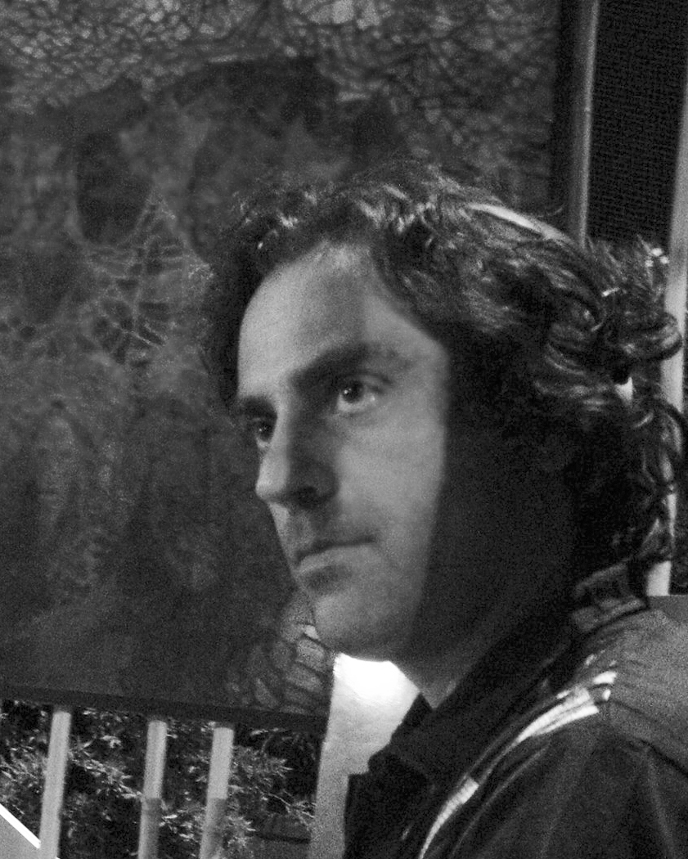

STUDIES
- Diploma of Art master "Sculpture Section", achieved in 'a.s. 1992/93, at the State Institute of Art F. Palizzi Naples.
- Degree Restoration 1995/96 (obtained at Assefor Pompeii) 1200 hours co-financed by the Campania Region.
- Graphic Designer graduate degree from Cambridge School of Design (Cambridge) in 2001.
WORK WITH THE ASSOCIATION "THELEMA" STUDIES AND HERMETIC templarism SINCE 2009
FONDA OWN ASSOCIATION "Juryo" IN 2011
FOREIGN LANGUAGES:
- Good knowledge of English, both spoken and written, (stay in the UK, in Cambridge, 2001/2002.
- Good knowledge of the Spanish language
COMPUTER KNOWLEDGES
- Excellent knowledge of major software (including Office), graphics, desktop publishing and web design: Corel Package, iMovie, MovieMaker, Final Cut, Adobe and Macromedia, both Win and Mac. European Computer Driving Licence.
EVENTS:
2016 MUSEUM OF CONTEMPORARY ART ROME MACRO
GRAMMELOT- ARTS FESTIVAL 18-19-20 March ROME.
DENARIUS TERRARUM OPERA EXPOSED
2015 October 17 KEPLER 999 ROME FOUNDRY OF ARTS EXHIBITION OF CONTEMPORARY ART WORKS INSPIRED THE UNIVERSE, THE SPACE, AND THE NOBEL PRIZE FOR PHYSICS Werner Heisenberg.
THE BOOK PAINTING
2015
September 27 CASTEL DELL'OVO WORK DEDICATED TO Gabriele D'Annunzio FIRE, EXPOSED IN THE HALLS OF THE CASTLE.
CAVEA
2015 LUGLIO August 18 to 15 WATERFRONT NAPLES ROUND DIAZ PARTHENOPE VILLAGE
PAINTINGS, PERFORMANCE AND VIDEO ART OF ROLANDO ATTANASIO
CAVEA IS A CAGE BUILT AROUND THE ARTIST OF THE SYSTEM that materializes imprisoning IDEAS, CAVEA IS A CONTEMPORARY CRY, THE CRY OF AN ARTIST NOT ALIGNED TO FREE ART SYSTEM, POLICY, THE CRY OF RESEARCH ABOUT TRUTH EVEN ACHES.
FoodCulture & SlowArt Milan
2015 May - Space Hi - Tech, at the headquarters of Crackingartgroup - Milan
Anita Agresti, Stéphane Ait Quarab, Rolando Attanasio, Vighen Avetis, Anna & Rosaria Corcione, Giuseppe Corcione, Luisa Corcione, Gianluca de Bartolo, Massimo D'Orta Ada Ferrante, Salvatore Menale, Emmanuelle Renard, Loredana Salzano, Roberto Stella, Mauro Visentin, Annamaria Volpe
April 2014 PUBLIC AN E-BOOK WITH AMAZON. A COLLECTION OF POEMS IN ITALIAN TRANSLATED INTO ENGLISH
2013 PAN MUSEUM OF NAPLES> GEOGRAPHY SPACE, VIDEO PRESENTATION "ATLANTIS".
2012 CANTALUPO IN SANNIO August 11 PRESENTATION OF THE BOOK BLUE LOBSTER IN THE GARDEN OF POETIC MARIA Aramanda, IN THE PRESENCE OF THE MAYOR AND THE PRESS. BIG TURNOUT FOR PUBLIC.
2012 Saturday, July 28, 2012, the exhibition "Mediterranean Bracing", curated by Maurizio Vitiello, with recent works by Rolando Attanasio.
2012 MALE ANGIOINO NAPLES 4-5-6 July, FAIR FROM TITLE: BLUE CONFUSED WITH PRESENTATION OF THE VIDEO OMONIMO MADE BY ROLANDO ATTANASIO AND CONSTRUCTION OF WORKS OF BARONS Antechamber.
2012 April, FINISHED PRINT THE NOVEL-THEATRE-POETIC: BLUE LOBSTER, INAUGURATION DAY May 4, 2012 18:00 AM TO LIBRARY LOFFREDO VOMERO IN NAPLES. PREFACE THE BOOK OF MAURITIUS Vitiello SOCIOLOGIST KNOWN AND ART CRITIC NAPOLETANO. BOOK WRITTEN BY ROLANDO ATTANASIO EDITIONS ERACLE in distribution DA: FELTRINELLI, LOFFREDO TREVES AND NAPLES.
2012 LONDON UK February Saachi GALLERY LONDON. EXHIBITION OF WORKS AND DIGITAL PAINTING
3/11 December 2011 FLORENCE, INTERNATIONAL BIENNIAL OF CONTEMPORARY ART the Fortezza da Basso, EXHIBITS ITS MANIFESTO ON CONTEMPORARY ART: ULTRAMETAFISICA AND TWO WORKS OF DIGITAL ART: 200042 E Y2K Y2K, INTERVIEWED BY VIATICUM ART MAGAZINE, JOURNAL OF NATIONAL SURVEY ON 'ART BY JOURNALIST: ANNALISA palombino.
27/28 September 2011 NAPLES, CONTEMPORARY ART GALLERY FRANCO RICCARDO P.ZZA NILE 7, rid THEATRICAL REVIEW AND VISUAL ARTS. (FROM: ALL NORMAL) TWO TEXTS WRITTEN BY ROLANDO ATTANASIO AND DIRECTED BY NICOLA Laieta, VIDEO FACILITIES OF PAINTING ON THE THEME: VO_MITO OF ROLANDO ATTANASIO. ACTORS: ROLANDO ATTANASIO, NICOLA Laieta, MATTIA DOTO IRENE AND OLD.
Thursday, 23 June 2011 Naples, Bulla The business incubator way S.Donato Duke 73, The power of the revealed signs (Alchemy and Symbolism), personal exhibition and launch of a jewelry line inspired by the work of symbolic paintings by Rolando Attanasio.
2010 December 12 Naples, Study Centre County via Roma 418, Art
Eclectic in Contemporary Tradition, introductory exhibition of Ultrametafisica Rolando Attanasio painting
2010 Friday, November 19 at 21 Castle St. Elmo - Napoli "Censored Opera", a painting hung on a wall is autocensurato, of pure protest ... Act on the events involving the artistic director Cicelyn and the scandal of the Madre Museum of Naples
July 2010 "The look that transforms and Thelema Association, in collaboration with WWF and the town of Naples. Video projection: What will they say about us? Adapted from the play: All Normal.
2009 September Castello Estense Ferrara "Symbolica: the magical dimension of Art"
2009 August Performance Neo situationist in Naples, Ferragosto. (Pedamentina lido, on the Pedamentina inS.Martino stairs), Public Art Event protest against the inefficiency of the Municipality and the Region.
2009 July poetic Center "Gran de concurso poetry en Espanol (Madrid)
Finalist an anthology translated into Spanish "The five known language", he will be part of a collection of poems in print titled Dulce spring in distribution on Spanish territory.
2009 May Zedda Publisher (Cagliari) Printed the political satire essay: "Politically Incorrect".
In June 2009 Poets competition among the stars U.A.I, University Federico II. three poems are published on space (the Milky Way, the center of the universe and Ode to the sun)
2009 Naples dramatized reading of some poems (March 20, 2009 18:00 0re) Association A Voce Alta in collaboration with Teatro Galleria Toledo
It presents: "Cocktail Readings"
Fragments of Women Patrizia Di Martino recital
reading texts by contemporary authors Plath, Copioli, Gualtieri, Attanasio
With: Patrizia Di Martino, Marcella Vitiello, Maurizio Captan
Napoli, 2009 (February 23, 2009 at 21.00) ExtraCandoni Nuovo Teatro Nuovo, scenic readings: "Job Interview", drawn by Piece "ALL NORMAL Rolando Attanasio.
2008 CODEX Campania, publication of five short films for the PICO (Permanent Virtual Library)
2008 June Poets among the stars U.A.I, University Federico II. three poems are published on space
2007 should be staged its theater piece at the Teatro Galleria Toledo in Naples March 27 to 28 "Doctors are born"
2006 Scene: "Doctors are born" Author and Director, Ascoli
2005 Exhibits two paintings, rocambolicamente hung in the air, in the charming frescoed space Refectory of S. Domenico Maggiore Naples -the vernissage entitled: "A breath of fresh air- art, eighth festival of performing arts and visual, November 12 to 19 .
2004 is among the artists selected to young artists Biennale Campani with the paintings Nettuneapolis.
2004, two digital art works are selected by a Japanese magazine (Japan) "12 th international internet art / photo contest" -y2k 20044 20043 alpha-y2k
He has worked on some scenes in 2003-2004, including that of the famous playwright Napoletano Manlio Santanelli, of which he staged with actor Neapolitan Carlo Puzio and Gennaro Patrone "memory disorders." He studied at the Academy of Fine Arts in Naples, graduated in Restoration Pictorial and has deepened the study of color and modern digital media, with Art and computer graphics applications. From 2002 to 2003 he lived in Cambridge UK, coming into contact with the artistic world of graphics and the Anglo-Saxon painting, working as a freelancer for several advertising agencies. 2005 September, it finishes writing the work of "POLITICALLY INCORRECT political satire"
Meanwhile accrue experiences in the field of philosophy, which nourishes a free and imaginative passion, alongside the artist-Neapolitan philosopher Maurizio Electric 2004- (Turin) International Art Fair "Room of baby Pope", he collaborated on designing and creating graphics 3D for the exhibition "ARTISSIMA" and then in 2004, the Museum of Capodimonte (Napoli) 23Novembre2006-07Gennaio2007 "SQUIRREL aND tHE GRAIL with Maurizio Electric" digital video "the Pope's room and Naples 2111, digital implementation for the video of the pope based on the book tHE NEW EMPIRE.
He plays the role of Hamm from Endgame by Samuel Beckett theater
Cilea Naples. In 2002 he lectured on color and contemporary painting, with particular reference to the trans Achille Bonito Oliva and the German Neue Wilden. He is interested in neo-experimentalism pictorial and poetic, in 1999 begins the collection of poems that keeps for years, it continues to write more about space and about love, about social doubts and concerns of contemporary man, developing a poetic whole staff , introspective and poignant.
She works for some commercial art and graphic agencies as a pager.
2004- (Naples) February 24 "Exhibition of Digital Art" title "Digital Dream" with Ugo Piscopo journalistic book reviews "The Morning (Daniela Ricci), La Repubblica, Il Corriere del Mezzogiorno, Naples City"
2002- realizes a personal painting contaminated entitled "Pittoricesimi" (Naples) in October, the staff Atelier Art Gallery curated by Ugo Piscopo
journalistic book reviews "The Morning (Daniela Ricci), La Repubblica, Il Corriere del Mezzogiorno, Naples City"
Conducts workshops, courses in graphics, painting and multimedia experimentation, which work together several artists, musicians, actors and painters. And 'contact in 2004- (United Arab Emirates) 30 December Sharjah Art Museum.
2005- (Caslano - Switzerland) Photo Contest "Vincenzo Vicari" Foundation where he exhibited some digital processing of photos.
WORK WITH THE SITE OF NATIONAL POETRY: POESIAEPOETI THAT
EDITOR'S WORK HOW TO MONTHLY MAGAZINE NATIONAL: FENIX
THE VOICE: WWW.POESIEEPOETI.IT CONTAINS A COLLECTION OF POEMS OF YOUTH. TO VISITS ON THE WEB
ARTICLES PUBLISHED ONLINE
WORK AS A WRITER SINCE 2007 WITH THE MAGAZINE
Whipart- (Publication registered in the register of newspapers and magazines at the Court of Trani);
Some famous articles of Art and Society:
2007. - modern and contemporary art Eros in Basel;
- Spirals of pleasure. Takato Banned on display in Rome, Whipart; 2007.
- Nudes, an exhibition by Tom Wesselmann; Whipart; 2007.
- Gender Bender 2008- The identity of sex through art; Whipart; 2008.
- The provocative blood and sadomasochistic Hermann Nitsch, Wh ipart; 2008 The direction of Leonardo.
2009 Anais nin and the Hungarian adventurer
2009 This lyrical and sensual scene of Patrizia Di Martino
2009 Rabindranath Tagore the poet of love and cosmic introspection
2009 Naples ... Why? The real eroticism is through a hole
2009 wedding at the Incas, the Mayas and Aztecs, and an experiment of Asch
2009 Tax Porn, Porn on the tax and the Italian Politics
2009 Apollonius between culture and sensuality Art
2009 Coercion contemporary and contemporary dictatorship
2009 A summer at the Lido Pedamentina
2009 Songs: Carmina Burana
FAI NEWS (Make Citizen journalism news - Citizen journalism; 2008.)
- The power of the ordinary citizen;
- The pill of unconsciousness; Make News - Citizen journalism; 2008.
- Very Serious missed opportunity by the FAO Summit -
2009 The theater nepotistic figure who we love
2009 invasion of the Huns in the church of the Florentines in Naples
Courier midday
2009 (Click / Theatre Critic: L'Européenne by David Lescot)
(Click / Theatre Critic: Taverna East- Super Dobro and Saint Lucia Of the beautiful Hope)
(Click / Theatre Critic: Elizabeth and Lemon)
e-mail: rolandoattanasiorolandus@gmail.com

link books:

http://www.mondadoristore.it/Aragosta-blu-Rolando-Attanasio/eai978889656196/

http://www.amazon.co.uk/Windward-Poems-counter-Annalisa-Palombino-ebook/dp/B00LDCI240

https://books.google.it/books/about/Politicamente_scorretto.html?id=Q-aePgAACAAJ&redir_esc=y

