C a t h e r i n e T h u r n e r

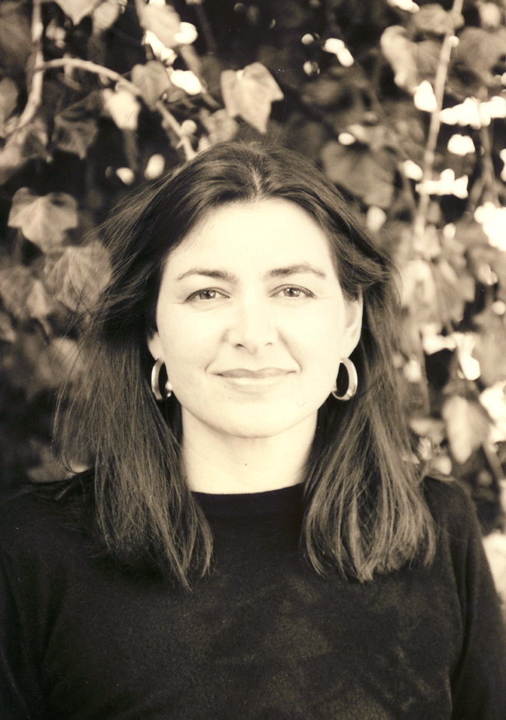

the adventure of life

Catherine Thurner comes from a distinguished Austrian-Belgian artistic family. Born in 1961, she grew up in the magical Mozartian city of Salzburg, a power house of creativity. Her father was a professor at the well known Salzburg music academy, the Mozarteum. As a violinist in the Camerata Academica he toured all over the world, creating in his children the foundations of a longing to discover the world.

At fifteen, Catherine moved to the artistic metropolis of Paris. Living alone in a room in Montmartre, she spent her solitary evenings painting the dusky backyards and seeking inspiration from the artistic scene. After three years at the Lycée Edgar Quinet she completed her baccalaureate, with art as her special subject.

Venice was her next stop. She studied the language and was fascinated by the incomparable water colours of William Turner, whose colours so uniquely reflect the magic of the city of lagoons.
Back in Salzburg, she first sought to express herself in the theatre, attending the Mozarteum drama school and attracting attention with major theatrical roles such as Medea and Iphigenia.

Her path then took her to Vienna, where she worked in the media and television. In this period it was speech, writing – communication – that determined her life. In Milan she worked for the Italian television company Canale Cinque, and then for ORF. She wrote articles, and designed radio and television productions for an international media agency which took her all over Europe and the world – from Moscow to New York, the Russian constructivists Kupka and Lentulov making as lasting an impression on her as the gigantic canvases of Jackson Pollock.

Only after her marriage did she return to her beloved home town of Salzburg – and to her first love, painting. She studied at the Bad Reichenhaller Akademie, completed numerous master courses and experimented with new ways of artistic expression. The lively dynamism and the expressive gestures of the actress flow into the activity of painting just as much as the boldly spiritual and intellectual part of her: «Painting for me is like dancing. Every picture has its own rhythm which determines how the brush is guided.» Colour is of special importance, for it expresses what has characterised Catherine Thurner’s life so far:
«The world as a fantastic place full of possibilities, full of inspiration – if you open your eyes to the outside world, and at the same time into your inner self, you can discover all these possibilities.»

Christoph Santner
Journalist, Salzburg

