Hideyuki Shoji

Hideyuki Shoji is a Japanese artist who works and lives in London. He was born in Yamagata Japan and he started his carrier of artist as a printmaking artist after graduated the Master degree at Yamagata University in Japan. He studied abroad to England and graduated from the Chelsea College of Art and Design with a BA (Hons).
A recurring theme in Hideyuki’s work involves curiosity in and observation of everyday life. To make the everyday apparent, his work makes an absurd alteration to an object before putting it back into an everyday life situation.
Hideyuki’s works often dealt with print and sculpture: using commonplace materials and suggesting alternative points of view within a social situation. To further exploit the realm of the unnoticed and overlooked within the complexities of everyday life, his work has become more performative recently. The works are no longer purely sculptural. He intervenes in a social structure with a performative activity, highlighting through a funny situation the otherwise everyday.

1978 Born in Japan
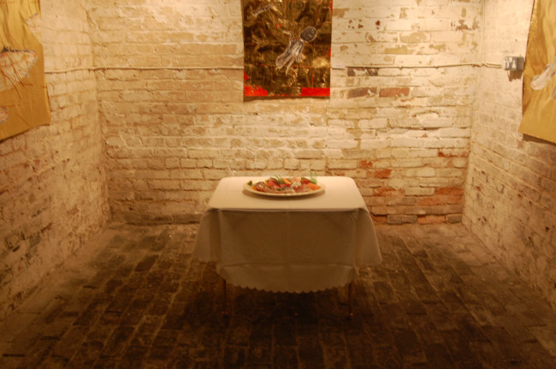
2005 Move to London

EDUCATION
2009 Chelsea College of Art and Design, BA Fine Art (Hon), UAL, UK
2004 Yamagata University, MA Education of Art and Design, JAPAN
2002 Yamagata University, Education of Art and Design, JAPAN

Awards
2002 ‘Yoshiwara Jiryo Award’ shortlisted, Osaka,Japan.
Exhibitions
2011 ‘Japanese Contemporary art exhibition’ Crypt Gallery, London, UK
2010 ‘Dream exhibition’ Shoerditch town hall, London, UK
2010 ‘Japanese Art festival’ Richmond adult community college, London UK
2005 ‘Session 2005’, Art Centre Cube, IWATE, JAPAN
2003 ‘PRINTS21’, Tokyo, JAPAN
2002 ‘Environment and City Art Exhibition’, Nigata, JAPAN
2002 ‘Cultural life Exhibition’, Kumamoto, JAPAN
2002 ‘YOSHIWARA JIRYO AWARD Exhibition’, Osaka, JAPAN
contact Mobile: 07578926676
E-mail: pikapiso@hotmail.com Web: http://www.hideyuki.nobody.jp

