**CURRICULUM VITAE**

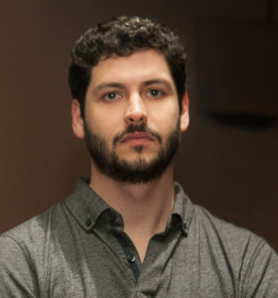

**Luiz Heinzen**

[lvizheinzen@gmail.com](mailto:lvizheinzen@gmail.com)

**WEBSITES:**

instagram.com/lvizheinzen

saatchiart.com/luizheinzen

facebook.com/lvizheinzen

**ART EDUCATION:**

2013/2015 - Painting course.

2014/2016 - Participation in the research group focused on fine arts – "NACASA – Coletivo Artístico”.

**EXHIBITIONS:**

Collective:

2017, **“Ponte Cultural”**, Stockholm, Sweden.

2017, “**XI Salão Nacional Victor Meirelles**, Florianópolis, Brazil.

2016/2017, **“Horizontes Possíveis”**, Centro Integrado de Cultura – CIC, Florianópolis, Brazil.

2016, **“MOSQ 2016 – Feira de Artes Visuais”**, Florianópolis, Brazil.

2015, **“Paisagens de Si – revisando”,** Assembleia Legislativa do Estado de Santa Catarina, Florianópolis, Brazil.

2015, **“Paisagens de Si”**, Câmara Municipal de Ourém, Ourém. Portugal.

2014, **“Narrativas em processos (ruído II)”**, Assembleia Legislativa do Estado de Santa Catarina, Florianópolis, Brazil.