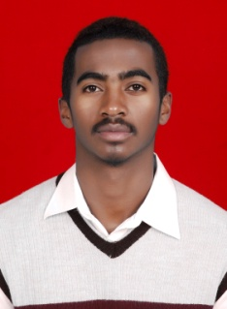***PERSONAL INFORMATION***

***Full name :*** *FANANANTSOA Jean Eddy (Eddy Bessa)*

***Date and place of birth*** ***:*** *Madagaskar (Ambalavao) 30January 1990*

***Nationality :*** *Malagasy*

***Mobile :*** *+62 85 766 540 610*

***E-mail :*** *jfananantsoa@yahoo.fr*

***OBJECTIVE***

*To improve more and more my own talent and have a great hard work and experience in Art*

***EDUCATION AND QUALIFICATION***

*Graduated from Madagascar High School 2010*

*Graduated of Bachelor degree from University of Fine Art ISI**Padangpanjang (Painting) 2016*

*Master degree at ISI Yogyakarta (Painting, sculpture, design) 2016-2018*

***OTHER SKILLS***

*Sculpture, design, Art exploration.*

***EXPERIENCE***

*4 years experience of working in a workshop painting*

*3years experience of managing and joining exhibitions*

*2 years experience of exploration*

***HOBBIES***

*Learn new things*

*Gym, play basketball, boxing, photography.*

***LANGUAGES***

*Malagasy*

*French*

*English*

*Indonesia*